INTERNATIONAL COUNCIL FOR HARMONISATION OF TECHNICAL REQUIREMENTS FOR PHARMACEUTICALS FOR HUMAN USE

ICH HARMONISED GUIDELINE

**Clinical electronic Structured Harmonised Protocol**

**(CeSHarP)**

**ASP8062 Example**

|  |  |
| --- | --- |
| **Full Title:** | A Phase 1 Randomized, Placebo-controlled Study to Assess the Safety, Tolerability and Pharmacokinetics of Multiple Doses of ASP8062 with a Single Dose of Morphine in Recreational Opioid Using Participants |
| **Sponsor Protocol Identifier:** | 8062-CL-2002 |
| **Original Protocol:** | No |
| **Version Number:** | 1.1 |
| **Version Date:** | 30 JUL 2020 |
| **Amendment Identifier:** | 1.1 |
| **Amendment Scope:** | Local US |
| **Compound Code(s):** | ASP8062 |
| **Trial Phase:** | Phase I |
| **Sponsor Name and Address:** | Astellas Pharma  Global Development Inc.  1 Astellas Way Northbrook, IL 60062, US |
| **Regulatory Agency Identifier Number(s):** | IND 146215 |
| **Sponsor Approval Date:** | 30/JUL/2020 |

Sponsor Signatory:

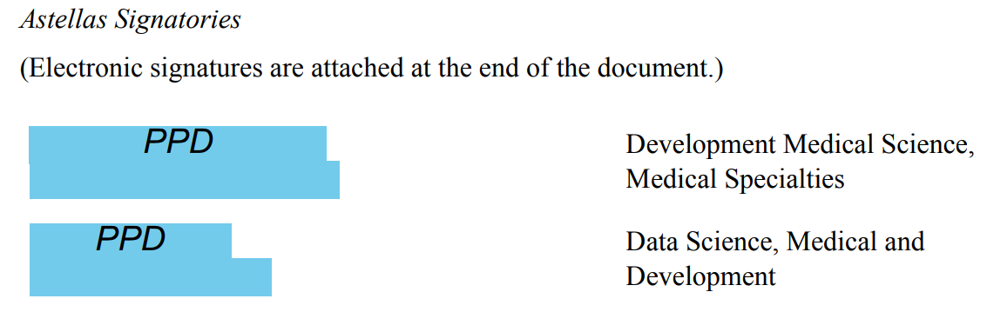

**Medical Expert Contact:**

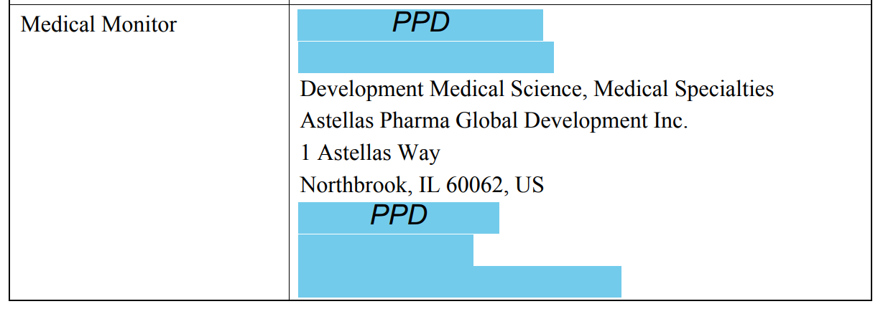

**SAE Reporting Method:**

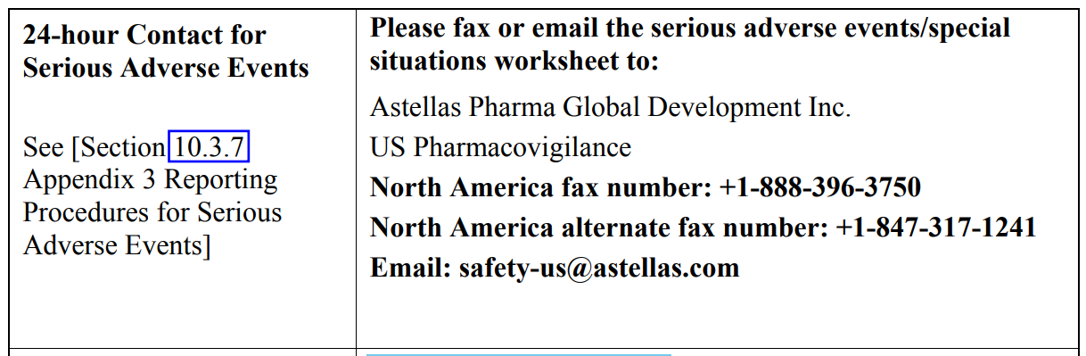

Amendment Details

This is the first protocol amendment.

Current Amendment

The table below describes the current amendment.

|  |  |  |  |
| --- | --- | --- | --- |
| **Approximate 0 Enrolled at time of Sponsor Approval:** | Approximate 0 enrolled | | |
| **{Reason(s) for Amendment:}** | Primary: Administrative | | Secondary: Not applicable |
| **{Amendment Summary:}** | This is a nonsubstantial amendment.amuuuSummStnent ementmmdmentmddndndmendment Summary | | |
| Is this amendment likely to have a substantial impact on the safety or rights of the participants? | | No | |
| Is this amendment likely to have a substantial impact on the reliability and robustness of the data generated in the clinical trial? | | No | |

**Overview of Changes in the Current Amendment:**

| Description of Change | {Brief Rationale for Change} | Section # and Name |
| --- | --- | --- |
| **Update screening language:**  Edit the rescreening language | To allow for the repeat of screening assessments within the screening window or to allow a subject to rescreen once for the study. Due to the nature of the participant population and the study design, subject safety and data integrity will not be impacted | 5.4.1 Rescreening |
| **Clarify inclusion and exclusion criteria:**  Move exclusion criterion 18 to the inclusion criteria and clarify the CYP450 enzymes that are excluded for exclusion criterion 19. | Previous exclusion 18 should be answered affirmatively in order for the subject to be eligible for participation; as a result, this exclusion should be listed as an inclusion. Exclusion 19 excluded all inducers of metabolism; however, after consideration, it is only necessary to exclude inducers of CYP3A4. | 5.2 Exclusion Criteria |
| **Clarify procedure for continuous end tidal CO2:**  Add clarification that subjects may remove cannula to dose or eat | The timepoints overlap for the collection of end tidal CO2 and it would not be possible for the subject to dose or eat with the cannula in place. | 7.2.8 Continuous and Spot End Tidal Carbon Dioxide, Table 5, Established Limits for End Tidal Carbon Dioxide |
| **Lower the respiratory rate alarm for continuous end tidal CO2 alarms:**  The alarm for respiratory rate low was 10 bpm and is now 6 bpm. | Generally, respiratory rates between 6 and 10 are not clinically relevant. A low respiratory rate alarm of 6 will allow a more accurate clinical determination of a true signal. | 7.2.8 Continuous and Spot End Tidal Carbon Dioxide, Table 5, Established Limits |
| **Edit Spot CO2 respiratory rate values:**  The spot values are lowered to start at > 24, and continue with increments of 4 bpm: >28, >32, and >36. | This change is made to align with the protocol, Table 7, alarm values. | 9.4.3.3 Vital Signs, Table 7, Criteria for Respiratory Rate |

Table of Contents

1 Protocol Summary 12

1.1 Protocol Synopsis 12

1.1.1 Primary and Secondary Objectives and Estimands 12

1.1.2 Overall Design 12

1.2 Trial Schema 13

1.3 Schedule of Activities 14

2 Introduction 17

2.1 Purpose of Trial 17

2.2 Summary of Benefits and Risks 17

2.2.1 Benefit Summary 17

2.2.2 Overall Benefit:Risk Conclusion 18

3 Trial Objectives and Estimands 19

3.1 Primary Objective(s) and Associated Estimand(s) 19

3.1.1 Primary Objective 19

3.1.2 Primary Endpoints 19

3.1.3 Primary Estimand: 19

3.2 Secondary Objective(s) and Associated Estimand(s) 19

3.2.1 Secondary Objectives 19

3.2.2 Secondary Endpoints 19

3.2.3 Secondary Estimands 19

3.3 Exploratory Objective(s) 19

3.3.1 Exploratory Objectives 19

3.3.2 Exploratory Endpoints 20

4 Trial Design 21

4.1 Description of Trial Design 21

4.2 Rationale for Trial Design 21

4.2.1 Rationale for Intervention Model 21

4.2.2 Background 22

4.3 Trial Stopping Rules 23

4.4 Start of Trial and End of Trial 23

4.5 Access to Trial Intervention After End of Trial 23

5 Trial Population 23

5.1 Description of Trial Population and Rationale 23

5.2 Inclusion Criteria 24

5.3 Exclusion Criteria 25

5.4 Contraception 26

5.4.1 Definitions Related to Childbearing Potential 26

5.4.2 Contraception Requirements 27

5.5 Lifestyle Restrictions 29

5.5.1 Meals and Dietary Restrictions 29

5.5.2 Caffeine, Alcohol, Tobacco, and Other Restrictions 29

5.5.3 Physical Activity Restrictions 29

5.6 Screen Failure and Rescreening 29

5.6.1 Screen Failures 29

5.6.2 Rescreening 29

6 Trial Intervention And Concomitant Therapy 30

6.1 Overview of Trial Interventions 30

6.2 Description of Investigational Trial Intervention 31

6.3 Rationale for Investigational Trial Intervention Dose and Regimen 31

6.4 Investigational Trial Intervention Administration 31

6.5 Investigational Trial Intervention Dose Modification 31

6.6 Management of Investigational Trial Intervention Overdose 31

6.7 Preparation, Storage, Handling and Accountability of Investigational Trial Intervention(s) 32

6.7.1 Preparation of Investigational Trial Intervention(s) 32

6.7.2 Storage and Handling of Investigational Trial Intervention 32

6.7.3 Accountability of Investigational Trial Intervention 32

6.8 Investigational Trial Intervention Assignment, Randomisation and Blinding 32

6.8.1 Participant Assignment to Investigational Trial Intervention 32

6.8.2 Randomisation 33

6.8.3 Blinding 33

6.8.4 Emergency Unblinding at the Site 33

6.9 Investigational Trial Intervention Compliance 34

6.10 Description of Non-Investigational Trial Intervention(s) 34

6.11 Concomitant Therapy 34

7 Participant Discontinuation of Trial Intervention and Discontinuation or Withdrawal From trial 35

7.1 Discontinuation of Trial Intervention for Individual Participants 35

7.1.1 Permanent Discontinuation of Trial Intervention 35

7.1.2 Temporary Discontinuation of Trial Intervention 35

7.1.3 Rechallenge 35

7.2 Discontinuation or Withdrawal from the Trial 35

7.3 Lost to Follow-Up 36

8 Trial Assessments and Procedures 37

8.1 Trial Assessments and Procedures Considerations 37

8.2 Screening/Baseline Assessments and Procedures 37

8.3 Efficacy Assessments and Procedures 37

8.4 Safety Assessments and Procedures 37

8.4.1 Physical Examination 37

8.4.2 Vital Signs 38

8.4.3 Electrocardiograms 38

8.4.4 Clinical Laboratory Assessments 38

8.4.5 Pregnancy Testing 39

8.4.6 Continuous Pulse Oximetry and Spot Blood Oxygen Saturation 39

8.4.7 Columbia-Suicide Severity Rating Scale 39

8.4.8 49-item Short Form of Addiction Research Center Inventory Scale 39

8.4.9 Continuous and Spot End Tidal Carbon Dioxide 39

8.4.10 Order of Assessments 40

8.5 Pharmacokinetics 40

8.5.1 Analysis of ASP8062 and Metabolites in Plasma 40

8.5.2 Analysis of Morphine and Metabolites in Plasma 40

8.6 Biomarkers 41

8.6.1 Genetics and Pharmacogenomics 41

8.6.2 Pharmacodynamic Biomarkers 41

8.6.3 Other Biomarkers 41

8.7 Immunogenicity Assessments 41

8.8 Medical Resource Utilisation and Health Economics 41

8.9 Total Amount of Blood 41

9 Adverse Events, Serious Adverse Events, Product Complaints, Pregnancy and Postpartum Information 43

9.1 Definitions 43

9.1.1 Definitions of Adverse Events 43

9.1.2 Definitions of Serious Adverse Events 44

9.2 Timing and Mechanism for Collection and Reporting 45

9.3 Identification, Recording and Follow-Up 45

9.3.1 Identification 46

9.3.2 Severity 46

9.3.3 Causality 46

9.3.4 Follow-up 48

9.4 Reporting 49

9.4.1 Regulatory Reporting Requirements 50

9.4.2 Adverse Events of Special Interest 50

9.4.3 Disease-related Events or Outcomes Not Qualifying as AEs or SAEs 51

9.4.4 Special Situations 51

9.4.5 Abnormal Laboratory Findings 52

9.5 Pregnancy and Postpartum Information 53

9.5.1 Participants Who Become Pregnant During the Trial 53

10 Statistical Considerations 54

10.1 General Considerations 54

10.2 Analysis Sets 54

10.3 Analyses of Demographics and Other Baseline Variables 55

10.4 Analyses Associated with the Primary Objective(s) 55

10.4.1 Statistical Method of Analysis 55

10.4.2 Handling of Data in Relation to Primary Estimand(s) 58

10.4.3 Handling of Missing Data 58

10.5 Analysis Associated with the Secondary Objective(s) 58

10.5.1 Statistical Method of Analysis 58

10.5.2 Handling of Missing Data 59

10.6 Analysis Associated with the Exploratory Objective(s) 59

10.7 Safety Analyses 59

10.8 Other Analyses 59

10.9 Interim Analyses 59

10.10 Multiplicity Adjustments 59

10.11 Sample Size Determination 60

11 Trial Oversight and Other General Considerations 60

11.1 Regulatory and Ethical Considerations 60

11.2 Trial Oversight 61

11.2.1 Investigator Responsibilities 61

11.2.2 Sponsor Responsibilities 61

11.3 Informed Consent Process 62

11.3.1 Informed Consent Process 62

11.3.2 Supply of New and Important Information Influencing the Participant’s Consent and Revision of the Written Information 62

11.4 Committees 62

11.5 Insurance and Indemnity 62

11.6 Risk Management 62

11.7 Data Governance 63

11.7.1 Data Protection 63

11.7.2 Dissemination of Clinical Study Data 63

11.7.3 Arrangement for Use of Information and Publication of the Study 64

11.7.4 Data Quality Assurance 64

11.8 Source Data 65

11.9 Protocol Deviations 66

11.10 Early Site Closure 66

12 Appendix: Supporting Details 68

12.1 Clinical Laboratory Tests 68

12.2 Country/Region-Specific Differences 69

12.3 Prior Protocol Amendment(s) 69

12.4 Liver Safety Monitoring and Assessment 70

12.5 Pharmacogenomic Analysis with Banked Sample 73

12.6 Columbia Suicide-Severity Rating Scale 74

12.7 49-item Short Form of Addiction Research Center Inventory Scale 79

12.8 Adverse Events of Interest Related to Potential Substance Abuse and Following Drug Withdrawal 83

13 Appendix: Glossary of Terms and Abbreviations 89

14 Appendix: References 91

1. Protocol Summary
   1. Protocol Synopsis
      1. Primary and Secondary Objectives and Estimands

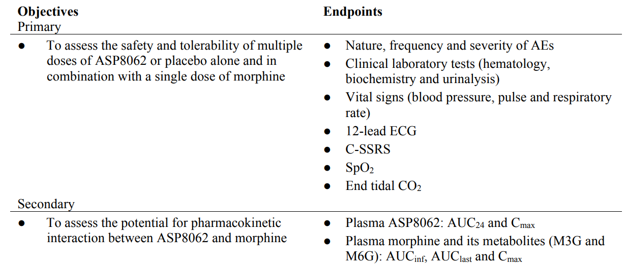

**Estimands** Not applicable.

* + 1. Overall Design

Key aspects of the trial design are summarised below.

|  |  |  |  |
| --- | --- | --- | --- |
| **Intervention Model:** | Open Label | **Population Type:** | Without disease |
| **Control Type:** | Placebo controlled | **Population Diagnosis or Condition:** | Opiod use |
| **Control Description:** | Placebo | **Population Age:** | Minimum: 18 years  Maximum: 60 years |
| **Intervention Assignment Method:** | Randomization | **Site Distribution and Geographic Scope:** | Single site |

**Number of Arms:** 3

**Trial Blind Schema:** Double-blind

**Blinded roles:** The following roles indicated will not be made aware of the treatment group assignment during the trial: participant, investigator

**Number of Participants:**

Approximately 24 male and female participants to complete at least 18 participants. An attempt will be made to enroll 1 female participant for every 3 male participants.

**Duration**

The anticipated duration of the study for each participant, including screening and follow-up, is approximately 53 days.

**Committees:**

Independent Committees: Not applicable.

* 1. Trial Schema

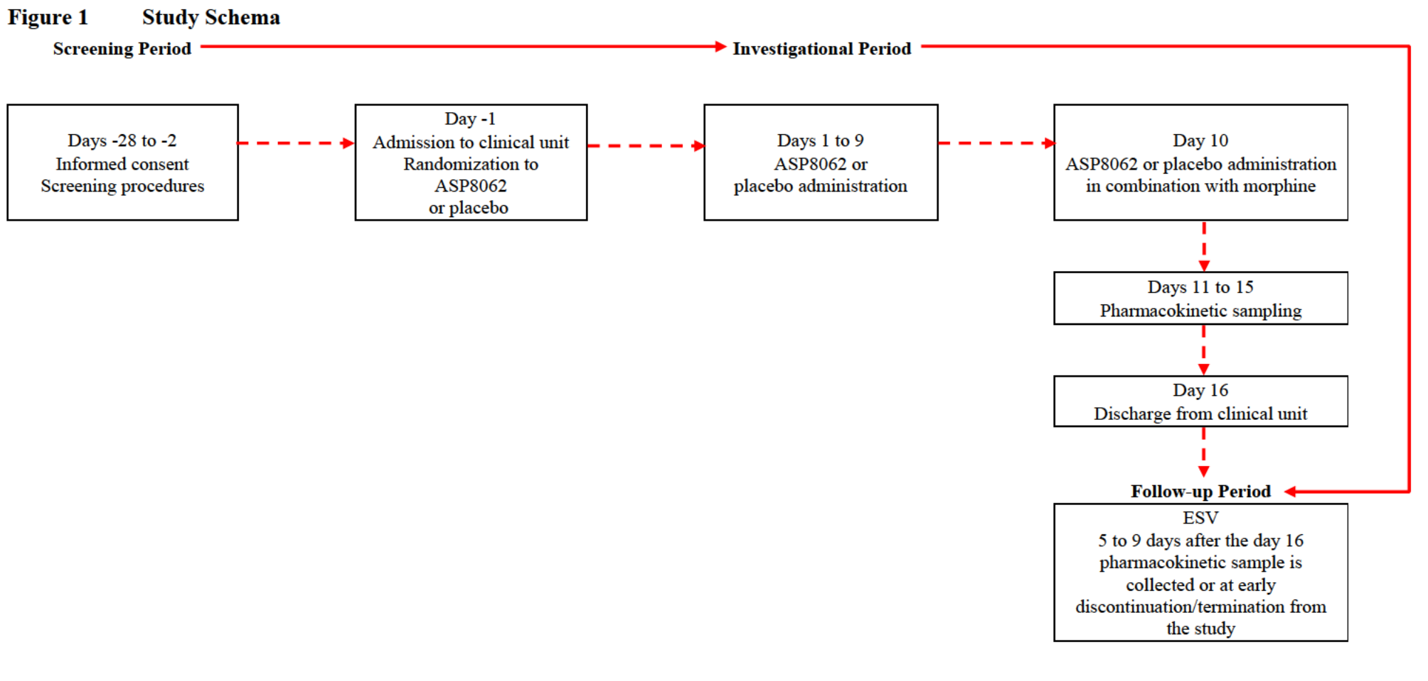

This will be a randomized, participant- and investigator-blinded, placebo-controlled, single sequence study comprising of male and female recreational opioid-using participants. Participants will be screened for up to 28 days prior to first investigational product administration. Eligible participants will be admitted to the clinical unit on day -1 and will be residential for a single period of 17 days/16 nights. After randomization, participants will receive multiple oral doses of ASP8062 or placebo (2:1 ratio) on days 1 through 10. On day 10, all participants will also receive a single oral dose of morphine immediately after the ASP8062 or placebo dose followed by a 144-hour in-house blood sampling period. Scheduled safety and tolerability assessments will be conducted as indicated in the Schedule of Assessments [Table 1]. Participants are to remain awake, seated or semirecumbent and avoid lying on either the left or right side for at least 4 hours postdose on days 9 and 10. Participants will be discharged from the clinical unit on day 16 on the condition that all required assessments have been performed and that there are no medical reasons for a longer stay in the clinical unit. The study will be completed with an end-of-study visit (ESV). The ESV will take place 5 to 9 days after the day 16 pharmacokinetic sample is collected or at early discontinuation/termination from the study.

* 1. Schedule of Activities

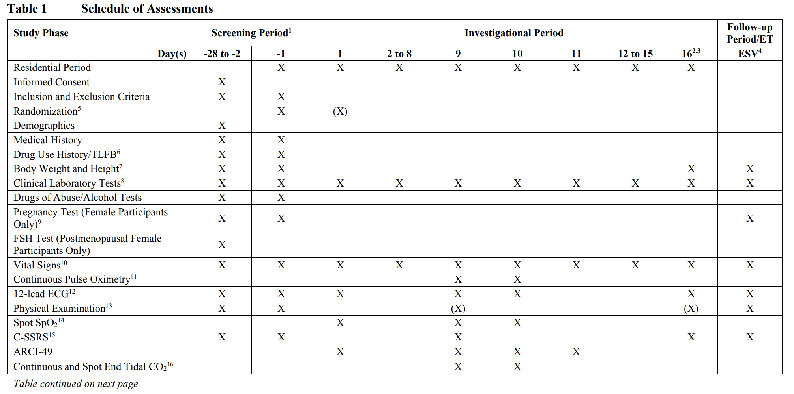

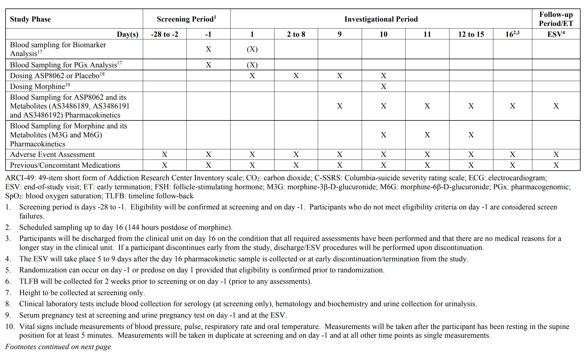

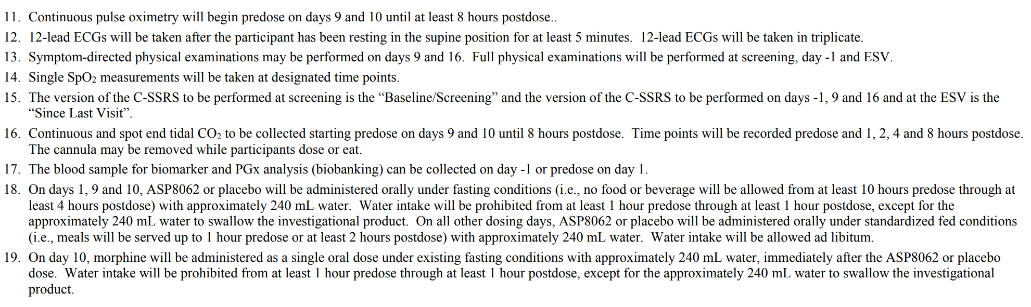

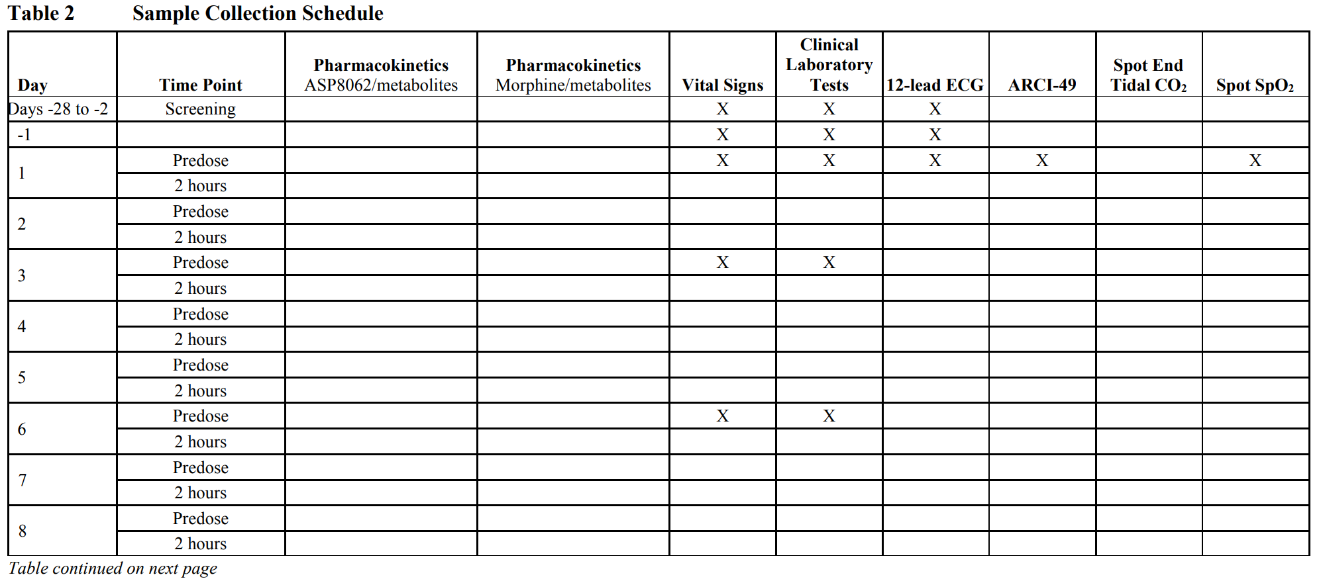

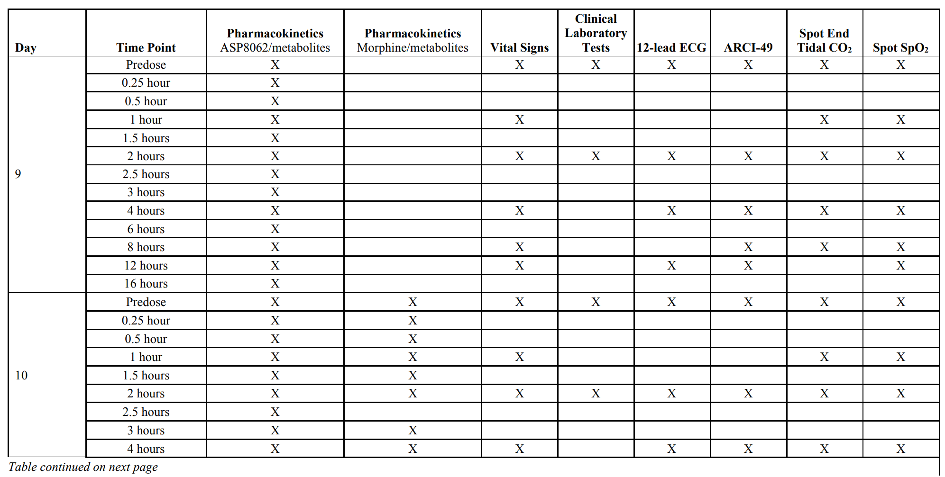

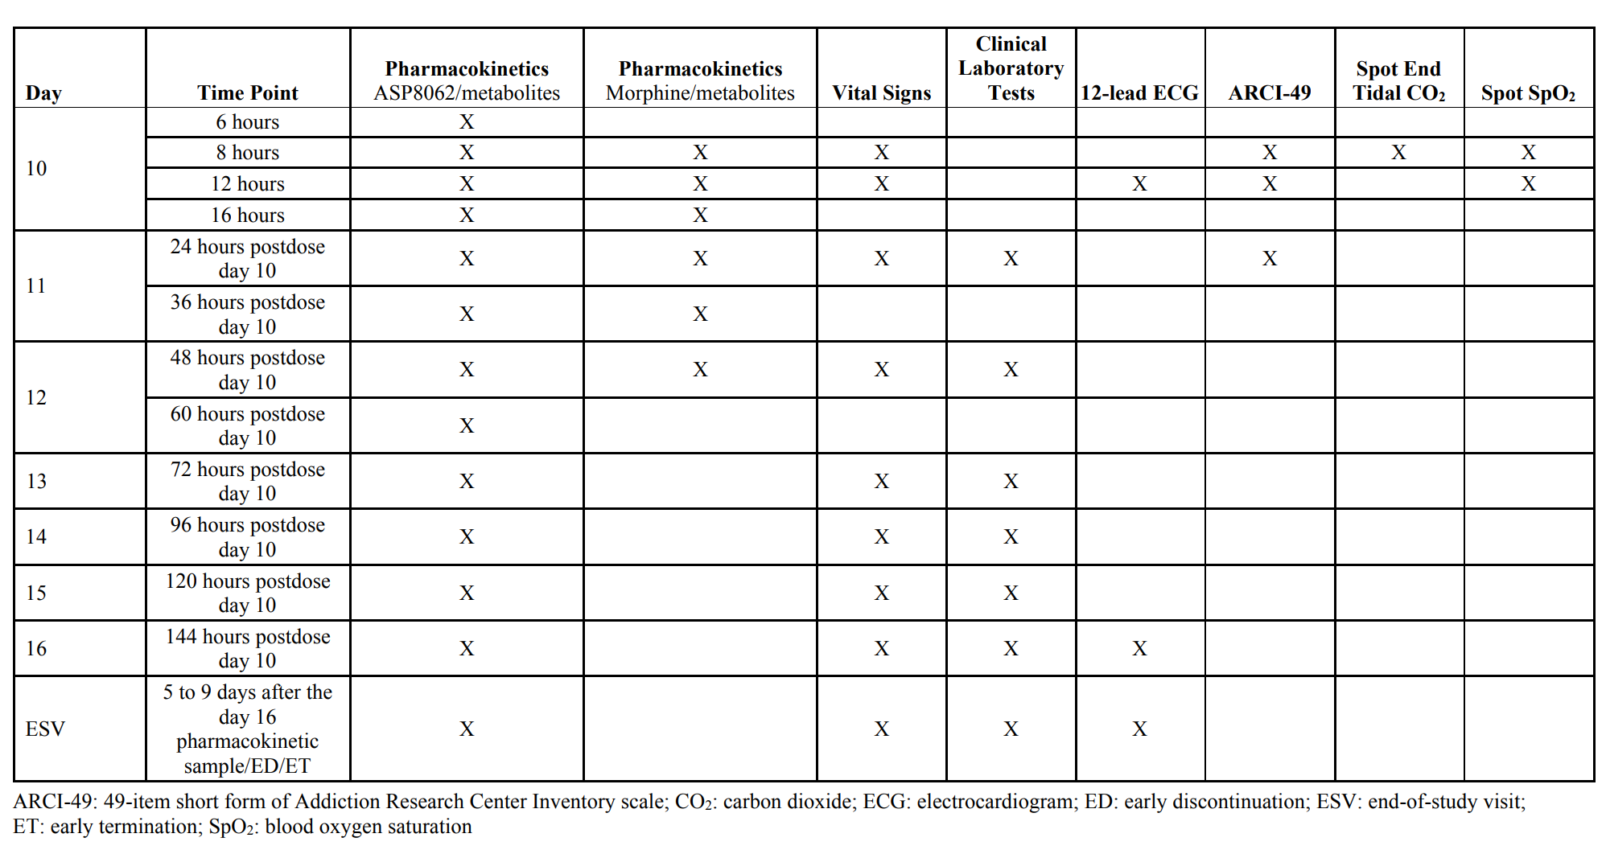

1. Introduction
   1. Purpose of Trial

ASP8062 has a potential to decrease use of illicit opioid drugs and improve the quality of life in patients with OUD. In the present study however where only a single daily 25 mg oral dose of ASP8062 will be administered for 10 consecutive days, there is no likelihood of a therapeutic effect. Given the safety profile of ASP8062 when administered to healthy participants, there appears to be relatively minimal risk to participants taking a daily 25 mg oral dose. The clinical unit has appropriately trained staff and required equipment available to treat participants presenting with both opioid withdrawal and morphine associated adverse events (AEs) including respiratory depression.

The risks of morphine immediate-release tablets are well known. Risks are mitigated in that only a single dose of morphine will be administered on day 10 following 10 consecutive daily administrations of ASP8062 [Morphine Sulfate Package Insert]. Risks are also minimized because the participants are confined at a clinical unit that has administered a range of opioids, including morphine. Side effects of opioids in general include respiratory depression, central nervous system depression and drowsiness, euphoria, feelings of relaxation, dependence, reduction of gastrointestinal motility, hepatitis with or without jaundice, allergic reactions, impairment in the ability to drive, orthostatic hypotension, elevation of cerebrospinal fluid pressure and intracholendochal pressure.

There is no expected benefit to the participants from the administration of morphine.

This will be the first study where a multiple daily oral dose of ASP8062 is administered in participants that will also be given morphine after the participants have reached near steady-state peak to trough exposures of ASP8062. Risks are minimized by confining participants in an experienced clinical unit testing the effects of approved medications or new chemical entities when combined with morphine. This study is also being conducted after the initiation of the phase 1b study examining a single dose of ASP8062 (60 mg) in participants also administered buprenorphine-naloxone at doses/exposures consistent with OUD standard of care. Continuous pulse oximetry and capnography for at least 8 hours will be employed on day 10 when ASP8062 is given with morphine so that the potential for respiratory depression will be noted immediately, and appropriate medical treatment may be given. Participants will also be monitored by experienced staff for signs of opioid withdrawal. Vital signs will be monitored daily from days 9 to 16 and electrocardiograms (ECGs) will be monitored on day 10 to detect potential cardiovascular symptoms several hours postdose. AEs will be assessed daily throughout the study. Potential hepatic toxicity will be monitored with clinical laboratory testing on at least a daily basis from days 10 to 16 of the investigational period. >

* 1. Summary of Benefits and Risks
     1. Benefit Summary

There is not expected to be a benefit from multiple consecutive daily oral doses of ASP8062 for 10 days in addition to a single oral dose of 45 mg morphine immediate-release tablets.

* + 1. Overall Benefit:Risk Conclusion

Participants in this study will not benefit from administration of ASP8062. In contrast, participants might experience AEs related to ASP8062 or procedural complications (e.g., blood draws, slight skin irritation from the adhesive on the ECG electrodes). Overall, the risk associated with the participation of recreational opioid using participants in this study is considered acceptable.

1. Trial Objectives and Estimands
   1. Primary Objective(s) and Associated Estimand(s)
      1. Primary Objective

To assess the safety and tolerability of multiple doses of ASP8062 or placebo alone and in combination with a single dose of morphine.

* + 1. Primary Endpoints
* Nature, frequency and severity of AEs
* Clinical laboratory tests (hematology, biochemistry and urinalysis)
* Vital signs (blood pressure, pulse and respiratory rate)
* 12-lead ECG
* C-SSRS
* SpO2
* End tidal CO2
  + 1. Primary Estimand:

Not applicable.

* 1. Secondary Objective(s) and Associated Estimand(s)
     1. Secondary Objectives

To assess the potential for pharmacokinetic interaction between ASP8062 and morphine.

* + 1. Secondary Endpoints
* Plasma ASP8062: AUC24 and Cmax
* Plasma morphine and its metabolites (M3G and M6G): AUCinf, AUClast and Cmax
  + 1. Secondary Estimands

Not applicable.

* 1. Exploratory Objective(s)
     1. Exploratory Objectives
* To assess additional safety and tolerability of multiple doses of ASP8062 or placebo alone and in combination with a single dose of morphine.
* To assess the general pharmacokinetic parameters of ASP8062, its metabolites, morphine and its metabolites.
* To assess the potential for pharmacokinetic interaction between ASP8062 and morphine via metabolites.
  + 1. Exploratory Endpoints
* Oral temperature
* ARCI-49
* Plasma ASP8062: CL/F, t½, tmax, tlag, Vz/F, Ctrough and PTR
* Plasma ASP8062 metabolites (AS3486189, AS3486191 and AS3486192): Cmax, AUC24, t½, tmax, tlag, Vz/F, Ctrough and PTR
* Plasma morphine and its metabolites (M3G and M6G): AUCinf(%extrap), CL/F (morphine), t½, tmax, tlag and Vz/F
* Plasma ASP8062 metabolites (AS3486189, AS3486191 and AS3486192): AUC24 and Cmax

1. Trial Design
   1. Description of Trial Design

This will be a randomized, participant- and investigator-blinded, placebo-controlled, single sequence study comprising of male and female recreational opioid-using participants. Approximately 24 male and female participants will be randomly assigned to complete at least 18 participants. An attempt will be made to enroll 1 female participant for every 3 male participants. The study will be conducted at 1 study site in the US.

Participants will be screened for up to 28 days prior to first investigational product (IP) administration. Eligible participants will be admitted to the clinical unit on day -1 and will be residential for a single period of 17 days/16 nights. After randomization, participants will receive multiple oral doses of ASP8062 or placebo (2:1 ratio) on days 1 through 10. On day 10, all participants will also receive a single oral dose of morphine immediately after the ASP8062 or placebo dose followed by a 144-hour in-house blood sampling period. Scheduled safety and tolerability assessments will be conducted as indicated in the Schedule of Assessments [Table 1]. Participants are to remain awake, seated or semirecumbent and avoid lying on either the left or right side for at least 4 hours postdose on days 9 and 10. Participants will be discharged from the clinical unit on day 16 on the condition that all required assessments have been performed and that there are no medical reasons for a longer stay in the clinical unit.

The study will be completed with an end-of-study visit (ESV). The ESV will take place 5 to 9 days after the day 16 pharmacokinetic sample is collected or at early discontinuation/termination from the study.

* 1. Rationale for Trial Design
     1. Rationale for Intervention Model

An in vitro cytochrome P450 (CYP) identification study suggested that ASP8062 is mainly metabolized by CYP3A4, while morphine shows no inhibitory effect on CYP3A in an in vitro study [Haaz et al, 1998]. Morphine is metabolized by multiple UDP-glucuronosyltransferases [De Gregori et al, 2012; Sato et al, 2012; Court et al, 2003; Projean et al, 2003]. Therefore, the pharmacokinetic drug-drug interaction (DDI) potential of ASP8062 with opioids is considered to be low. Potential interaction such as opioid effects on respiratory depression is theoretically possible because both ASP8062 and opioids are centrally active [Pattinson, 2008].

For future studies in opioid use disorder (OUD) patients, ASP8062 will be coadministered with opioids, including standard medication-assisted treatments such as buprenorphine/naloxone. Among opioid receptors, the µ-receptor is considered to play a role in the decrease in the respiratory response to hypoxia, resulting in a decreased stimulus to breathe and the development of apnea [Schiller & Mechanic, 2019]. ASP8062 has not been observed to directly interact with opioid receptor [study 8062-PH-9005] and the preclinical DDI study [study 8062-PH-9055] between ASP8062 and morphine, a full agonist for opioid µ-receptor, failed to find any pharmacodynamic (i.e., respiratory depression) interaction including general condition. This clinical DDI/safety study will provide relevant safety (particularly for respiratory depression), tolerability and pharmacokinetic data in order to assess the potential risk of ASP8062 coadministered with morphine, a full agonist for opioid µ-receptor to support future studies in this patient population. The study was designed particularly to investigate if ASP8062 has any additive effect on top of morphine by instituting the sensitive measure of end tidal carbon dioxide (CO2), using a single morphine dose slightly above the highest approved individual morphine dose, but presumably still allowing room to detect potential additive effects of ASP8062.

A randomized, participant- and investigator-blinded, placebo-controlled, single sequence study was chosen to assess the safety and tolerability of multiple doses of ASP8062 alone and ASP8062 in combination with a single dose of morphine sulfate, a full µ-opioid receptor agonist. Participants will be randomized to treatment to reduce selection bias. Participants and the investigator will both be blinded to treatment to reduce bias in the measurement of the primary safety endpoints. Given the long pharmacokinetic t½ of ASP8062 (approximately 60 hours), a single sequence study was chosen.

* + 1. Background

ASP8062 is a novel compound with positive allosteric modulator (PAM) activity on the gamma-aminobutyric acid type B (GABAB) receptor that is intended for oral administration and is currently being developed for the treatment of OUD and alcohol use disorder. ASP8062 is a crystal, which is practically insoluble in water and slightly soluble in ethanol.

An estimated 2.1 million Americans had an OUD in 2017 [Substance Abuse and Mental Health Services Administration, 2018]. Overdose deaths due to opioid use have skyrocketed to over 47600 in 2017 [Scholl et al, 2018]. National Institute on Drug Abuse (NIDA) data show that use of opioids can lead to neonatal abstinence syndrome [NIDA, 2019a] as well as the spread of infectious diseases like human immunodeficiency virus (HIV) and hepatitis [NIDA, 2019b]. Medication assisted treatment with buprenorphine (with or without naloxone), methadone or naltrexone is the current standard of care, and has resulted in decreases in opioid use, overdose deaths, criminal activity and infectious disease transmission [Mattick et al, 2014; Schwartz et al, 2013; Mattick et al, 2009]. However, buprenorphine can induce withdrawal on first administration, has an overdose potential, induces withdrawal symptoms and a loss of tolerance on cessation, is also subject to abuse and diversion and can cause respiratory suppression. Buprenorphine’s ceiling effect may limit its effectiveness in patients with ongoing opioid use [Bart, 2012].

The Diagnostic and Statistical Manual of Mental Disorders, edition 5 (DSM-5) defines substance use disorders as a constellation of recurrent pathological cognitive, behavioral and physiological symptoms arising from the ongoing use of a substance. The DSM-5 has combined the Diagnostic and Statistical Manual of Mental Disorders, edition 4 categories of substance abuse and substance dependence under the single heading of substance use disorders, which is classified by severity based on the number of symptom criteria (out of a total of 11) that are met: mild (2 to 3 criteria), moderate (4 to 5 criteria) and severe (more than 6 criteria) [Hasin et al, 2013]. Different drugs produce different effects on the user, but important shared features include a dysregulation of brain reward pathways and an overactive brain stress system, which together reinforce use of the substance to achieve a pleasurable high, even if pursuing this high incurs great cost or negative consequences for the user.

Gamma-aminobutyric acid (GABA), the most abundant inhibitory neurotransmitter, activates 2 types of receptors: ionotropic GABA type A receptors [Olsen & Sieghart, 2008] and metabotropic GABAB receptors [Bowery et al, 2002]. Studies with GABAergic drugs and drugs of abuse have indicated that the GABAB receptor mediates suppression of self-administration/craving across several drug modalities. Drugs triggering abuse act by enhancing dopamine release in the ventral tegmental, striatal, and prefrontal cortical areas of the brain. The effects of GABAergic compounds on decreasing drug self-administration and drug-seeking behavior act by either directly or indirectly decreasing dopamine release in the aforementioned brain areas [Filip et al, 2015]. GABAB agonists or PAMs have been found to attenuate opioid-, alcohol-, cocaine- and nicotine-seeking behavior [Augier et al, 2017; Vlachou et al, 2011; Franklin et al, 2009; Filip & Frankowska, 2007; Paterson et al, 2004; Di Ciano & Everitt, 2003b; Di Ciano & Everitt, 2003a] and also attenuate the drugs of abuse-evoked changes during intracranial self-stimulation [Vlachou et al, 2011; Paterson et al, 2008; Slattery et al, 2005]. However, activation of GABAB receptors by orthosteric agonists such as baclofen induces side effects such as sedation, somnolence, excessive weakness, vertigo and cognitive impairment. The sedative properties of baclofen limits its potential widespread therapeutic utility [Dario & Tomei, 2004]. Accordingly, activation of GABAB receptors by PAMs is one of the prioritized medication treatment approaches for NIDA in response to the opioid crisis [Rasmussen et al, 2019].

For information on the nonclinical and clinical data of ASP8062, please refer to the [Investigator’s Brochure].

* 1. Trial Stopping Rules

Not applicable.

* 1. Start of Trial and End of Trial

The end of the study is defined as the last visit or scheduled procedure shown in Schedule of Assessments [Table 1] for the last participant in the study.

* 1. Access to Trial Intervention After End of Trial

Not applicable.

1. Trial Population
   1. Description of Trial Population and Rationale

All screening assessments must be completed and reviewed to confirm the potential participant meets all eligibility criteria. Prospective approval of protocol deviations to eligibility criteria (also known as protocol waivers or exemptions) is not permitted.

The study population will consist of male and female participants (18 to 60 years of age, inclusive) who have at least 10 lifetime uses of a recreational opioid drug with at least 1 opioid use in the last 90 days.

* 1. Inclusion Criteria

To be eligible to participate in this trial, an individual must meet all the following criteria:

1. Institutional Review Board (IRB)/Independent Ethics Committee (IEC)-approved written informed consent and privacy language as per national regulations (e.g., Health Insurance Portability and Accountability Act authorization for US sites) must be obtained from the participant prior to any study-related procedures (including withdrawal of prohibited medication, if applicable).
2. Participant is a male or female participant between 18 to 60 years of age, inclusive at screening.
3. Participant is a recreational opioid user who has used opioids for nontherapeutic (recreational) purposes on at least 10 occasions within their lifetime, with at least 1 opioid use in the last 90 days.
4. Participant has a body mass index (BMI) range of 18 to 36 kg/m2 , inclusive and weighs at least 50 kg at screening.
5. Female participant is not pregnant (see [Section 10.2 Appendix 2 Contraception Requirements]) and at least 1 of the following conditions apply:
   1. Not a woman of childbearing potential (WOCBP) (see [Section 10.2 Appendix 2 Contraception Requirements])
   2. WOCBP who agrees to follow the contraceptive guidance (see [Section 10.2 Appendix 2 Contraception Requirements]) from the time of informed consent through at least 28 days after final IP administration.
6. Female participant must agree not to breastfeed starting at screening and throughout the study period and for 28 days after final IP administration.
7. Female participant must not donate ova starting at first dose of IP and throughout the study period and for 28 days after final IP administration.
8. Male participant with female partner(s) of childbearing potential (including breastfeeding partner[s]) must agree to use contraception (see [Section 10.2 Appendix 2 Contraception Requirements]), throughout the treatment period and for 90 days after final IP administration.
9. Male participant must not donate sperm during the treatment period and for 90 days after final IP administration.
10. Male participant with a pregnant partner(s) must agree to remain abstinent or use a condom with spermicide for the duration of the pregnancy throughout the study period and for 90 days after final IP administration.
11. Participant agrees to not participate in another interventional study while participating in the present study.
12. Participant must be willing to abstain from smoking (including use of tobacco-containing products and nicotine or nicotine-containing products [e.g., electronic vapes]) from at least 1 hour predose through at least 8 hours postdose on days 9 and 10.
    1. Exclusion Criteria

Participant will be excluded from participation in the study if any of the following apply:

1. Participant has received any investigational therapy within 28 days or 5 half-lives, whichever is longer, prior to screening.
2. Participant has any condition which, in an investigator’s opinion, makes the participant unsuitable for study participation.
3. Female participant who has been pregnant within 6 months prior to screening or breastfeeding within 3 months prior to screening.
4. Participant has a known or suspected hypersensitivity to ASP8062 or morphine and/or other opioids, or any components of the formulations used.
5. Participant has had previous exposure with ASP8062.
6. Participant has any of the liver function tests (alkaline phosphatase [ALP], alanine aminotransferase [ALT], aspartate aminotransferase [AST], gamma-glutamyl transferase and total bilirubin [TBL]) ≥ 1.5 × upper limit of normal (ULN) on day -1. In such a case, the assessment may be repeated once.
7. Participant has any clinically significant history of allergic conditions (including drug allergies, asthma or anaphylactic reactions, but excluding untreated, asymptomatic, seasonal allergies) prior to first IP administration as judged by an investigator.
8. Participant has any history or evidence of any clinically significant cardiovascular, gastrointestinal, endocrinologic, hematologic, hepatic, immunologic, metabolic, urologic, pulmonary, neurologic, dermatologic, renal and/or other major disease or malignancy, as judged by an investigator, with exception of history of cholecystectomy.
9. Participant has a history of moderate or severe use disorder for any substance other than caffeine or tobacco (based on the DSM-5 criteria).
10. Participant has a history or presence of any clinically significant psychiatric disorders such as, bipolar 1, schizophrenia, schizoaffective disorder or major depressive disorders, as judged by an investigator.
11. Participant has had recent suicidal ideation within the last 12 months or participant who is at significant risk to commit suicide, as judged by an investigator, using the Baseline/Screening Columbia-suicide severity rating scale (C-SSRS) at screening and the Since Last Visit C-SSRS on day -1.
12. Participant has/had febrile illness or symptomatic, viral, bacterial (including upper respiratory infection) or fungal (noncutaneous) infection within 1 week prior to day -1.
13. Participant has any clinically significant abnormality following an investigator’s review of the physical examination, ECG and protocol-defined clinical laboratory tests at screening or on day -1.
14. Participant has a mean pulse < 50 or > 90 bpm; mean systolic blood pressure > 150 mmHg; mean diastolic blood pressure > 95 mmHg (measurements taken in duplicate after participant has been resting in the supine position for at least 5 minutes) on day -1. If the mean blood pressure exceeds the limits above, 1 additional duplicate may be taken.
15. Participant has a mean corrected QT interval using Fridericia’s formula (QTcF) of > 450 msec (for male participants) and > 470 msec (for female participants) on day -1. If the mean QTcF exceeds the limits above, 1 additional triplicate ECG may be taken.
16. Participant has a positive test for amphetamines, barbiturates, benzodiazepines, cocaine, phencyclidine, alcohol and/or opiates on day -1. Positive tetrahydrocannabinol is not exclusionary and a cannabis intoxication evaluation will be performed. Participant may be reconsidered at an investigator’s discretion.
17. Participant has used any prescribed or nonprescribed drugs (including vitamins and natural and herbal remedies, e.g., St. John’s Wort) in the 2 weeks prior to first IP administration, except for occasional use of acetaminophen (up to 2 g/day), topical dermatological products, including corticosteroid products, hormonal contraceptives and hormone replacement therapy (HRT).
18. Criterion Removed.
19. Participant has used any inducer of CYP3A4-related metabolism (e.g., barbiturates, rifampin, apalutamide, carbamazepine, enzalutamide, mitotane, phenytoin, St. John’s wort, bosentan, efavirenz, etravirine, phenobarbital, primidone, armodafinil, modafinil, and rufinamide) in the 3 months prior to day -1.
20. Participant has had significant blood loss, donated approximately 500 mL of whole blood (excluding plasma donation) within 56 days prior to screening or donated plasma within 7 days prior to day -1.
21. Participant has a positive serology test for hepatitis B surface antigen, hepatitis C virus antibodies or antibodies to HIV type 1 and/or type 2 at screening.
22. Participant has loss of ability to freely provide consent through imprisonment or involuntary incarceration for treatment of either a psychiatric or physical (e.g., infectious disease) illness.
23. Participant is an employee of Astellas, the study-related contract research organizations (CROs) or the clinical unit.
    1. Contraception
       1. Definitions Related to Childbearing Potential

WOMEN OF CHILDBEARING POTENTIAL DEFINITIONS AND METHODS OF CONTRACEPTION DEFINITIONS

A female is considered fertile (i.e., WOCBP) following menarche and until becoming postmenopausal unless permanently sterile.

**Females in the following categories are not considered WOCBP**

* Premenopausal with one of the following (i.e., permanently sterile): o
  + Documented hysterectomy
  + Documented bilateral salpingectomy
  + Documented bilateral oophorectomy
* Postmenopausal

A postmenopausal state is defined as at least 12 months after last menstrual bleeding without an alternative medical cause.

In case the last menstrual bleeding cannot be clearly determined, confirmation with more than 1 FSH measurement of at least > 40 IU/L (or higher per local institutional guidelines) is required.

Females on HRT and whose menopausal status is in doubt will be required to use 1 of the nonestrogen hormonal highly effective contraception methods if they wish to continue their HRT during the study. Otherwise, they must discontinue HRT to allow confirmation of postmenopausal status by repeated FSH measurements before study enrollment. Female participants must be on a stable dose of HRT for 2 months prior to day -1.

Documentation of any of these categories can come from the study site personnel’s review of the female participant’s medical records, medical examination or medical history interview.

* + 1. Contraception Requirements

WOCBP who are eligible for participation in the study, including those who choose complete abstinence, must have pregnancy tests as specified in the Schedule of Assessments [Table 1]. Pregnancy test results must confirm that the participant is not pregnant.

**CONTRACEPTION GUIDANCE FOR FEMALE PARTICIPANTS OF CHILDBEARING POTENTIAL**

Female participants of childbearing potential are eligible for participation in the study if they agree to use 1 of the highly effective methods of contraception listed below from the time of signing the ICF and until the end of relevant systemic exposure, defined as 28 days after the final IP administration.a

Highly effective methods of contraception (failure rate of < 1% per year when used consistently and correctly) b :

* A condom and spermicide
* Combined (estrogen- and progestogen-containing) hormonal contraception associated with inhibition of ovulation for at least 30 days prior to first dose of IP.
  + Oral
  + Intravaginal
  + Transdermal
* Progestogen-only hormonal contraception associated with inhibition of ovulation for at least 30 days prior to first dose of IP
  + Oral
  + Injectable o Implantable
* Other combined (estrogen- and progesterone-containing) methods for at least 30 days prior to first dose of IP
  + Vaginal ring
  + Injectable
  + Implantable
  + Intrauterine hormone-releasing system or intrauterine device
* Bilateral tubal occlusion or ligation
* Vasectomized partner

A vasectomized partner is a highly effective contraception method provided that the partner is the sole male sexual partner of the WOCBP.

* Sexual abstinence Sexual abstinence is considered a highly effective method only if defined as refraining from heterosexual intercourse during the entire period of risk associated with the test product. The reliability of sexual abstinence needs to be evaluated in relation to the duration of the study and the preferred and usual lifestyle of the participant. It is not necessary to use any other method of contraception when complete abstinence is elected.

a Local laws and regulations may require use of alternative and/or additional contraception methods.

b Typical use failure rates may differ from those when used consistently and correctly. Use should be consistent with local regulations regarding the use of contraceptive methods for participants participating in clinical studies.

**CONTRACEPTION GUIDANCE FOR MALE PARTICIPANTS WITH PARTNER(S) OF CHILDBEARING POTENTIAL.**

Male participants with female partners of childbearing potential are eligible for participation in the study if they agree to the following during treatment and until the end of relevant systemic exposure defined as 90 days after final drug administration.a

* Inform any and all partner(s) of their participation in a clinical drug study and the need to comply with contraception instructions as directed by the investigator
* Use a condom and spermicide
* Female partners of male participants who have not undergone a vasectomy or a bilateral orchiectomy should consider use of effective methods of contraception
* If sexual abstinence is practiced, sexual abstinence should be practiced from 30 days prior to screening and participant should agree to continue practicing sexual abstinence during study participation

a Local laws and regulations may require use of alternative and/or additional contraception methods

* 1. Lifestyle Restrictions
     1. Meals and Dietary Restrictions

To avoid false positive results of the drugs of abuse test, no food or drinks containing poppy seeds (e.g., specialty breads and muffins) will be allowed from 48 hours prior to admission to the clinical unit up to and including the ESV.

Participants will not be allowed to consume food and drinks which may interact with circulatory, gastrointestinal, liver or renal function from at least 24 hours for alcohol or xanthine-containing products (including caffeine) and 72 hours for grapefruit/Seville orange or grapefruit/Seville orange-containing products prior to admission to the clinical unit up to and including the ESV.

Participants will be served normal balanced caloric drinks and meals at consistent times during their stay in the clinical unit. Total daily caloric intake will preferably not exceed normal daily limits (approximately 2800 kcal/male and female participants). Dietary and fluid restrictions apply to dosing conditions as specified in [Section 6.1 Investigational Product(s)]. The menu and nutritional information will be documented in the clinical study file.

Standardized lunch and dinner will be served at fixed time points on day 1. On other days, the participants will receive standard meals.

* + 1. Caffeine, Alcohol, Tobacco, and Other Restrictions

Participants will not be allowed to smoke (including using tobacco-containing products and nicotine or nicotine-containing products [e.g., electronic vapes]) from at least 1 hour predose through at least 8 hours postdose on days 9 and 10 during measurements for continuous pulse oximetry and end tidal CO2.

* + 1. Physical Activity Restrictions

Participants will refrain from strenuous exercise from 48 hours prior to admission to the clinical unit up to and including the ESV.

Participants are encouraged to walk and stretch during the confinement period to avoid AEs associated with the sedentary environment.

* 1. Screen Failure and Rescreening
     1. Screen Failures

A screen failure is defined as a potential participant who signed the informed consent form (ICF), but did not meet one or more criteria required for participation in the study and was not randomized. For screen failures, the demographic data, date of signing the ICF, inclusion and exclusion criteria, AEs up to the time of screen failure and reason for screen failure will be collected in the electronic data source.

* + 1. Rescreening

Results of screening assessments that do not meet the parameters required by eligibility criteria (e.g., clinical laboratory tests, vital signs, physical examination, ECG, etc.) may be repeated once within the 28-day screening period without the need to register the participant as a screen failure. If the participant meets exclusion criteria that cannot resolve during the screening period, or more than 28 days elapse from the date of signing the ICF, the participant must be documented as a screen failure. In order to re-screen after prior screen failure, a new ICF must be signed and the participant entered into screening with a new participant identification number. Rescreening is only allowed once for an individual participant

1. Trial Intervention And Concomitant Therapy
   1. Overview of Trial Interventions

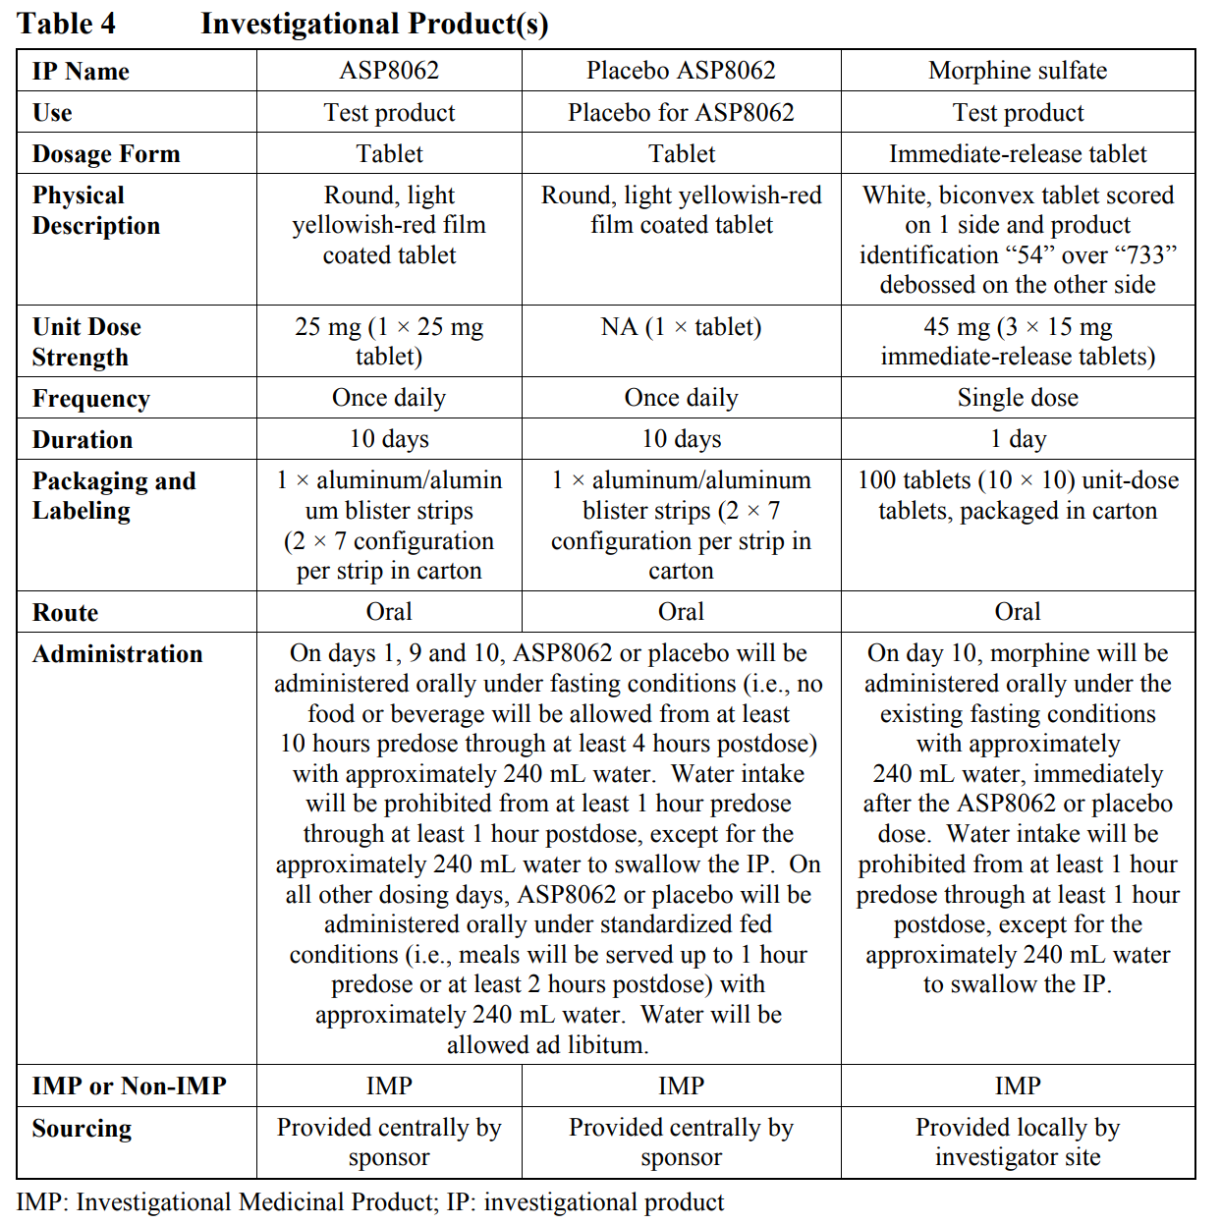

* 1. Description of Investigational Trial Intervention

*See Table 4 above.*

* 1. Rationale for Investigational Trial Intervention Dose and Regimen

The primary objective of this study is to assess the safety and tolerability of multiple doses of ASP8062 alone and ASP8062 in combination with a single dose of morphine sulfate, a full µ-opioid receptor agonist. In the 8062-CL-0005 study, the AUCs of 30 mg ASP8062 with tablet B formulation (provided as a 30 mg tablet) were approximately 10% higher than 30 mg ASP8062 with tablet A formulation (provided as a 25 mg tablet plus a 5 mg tablet) with the 90% CI within the standard bioequivalence limits (80.00, 125.00); Cmax was approximately 60% higher. With this finding, multiple doses of 25 mg ASP8062 with tablet B formulation will be proposed for future clinical studies for OUD. The predicted exposures after multiple doses of 25 mg ASP8062 are 1828 h•ng/mL for AUC24 and 143 ng/mL for Cmax. These exposures will be comparable to exposures in the previous clinical studies and will not exceed mean exposure limit set in previous phase 1 studies (247 ng/mL for Cmax and 2339 h•ng/mL for AUC24); which means exposures achieved in this study are expected to be pharmacologically active (as seen in 8062-CL-0003) and also safe and tolerated based on data from previous clinical studies in a total of 137 healthy participants and 95 fibromyalgia patients.

The single dose of 45 mg morphine sulfate is 1.5 times higher than the approved highest individual dose per package insert [Morphine Sulfate Package Insert]. This dose is equivalent to 30 mg oxycodone, which is 2 times higher than the recommended highest individual dose and considered to be sufficient to show a sign of µ-receptor agonism. Cmax after a single dose of 45 mg morphine sulfate immediate-release tablet is expected to be close to the reported maximum serum morphine concentration after intramuscular administration of morphine chloride (0.15 mg/kg body weight) in which most participants showed depression of the ventilatory response, characterized by the slopes of the carbon dioxide tension ventilation curves [Møller et al, 1982]>

* 1. Investigational Trial Intervention Administration

*See Table 4 above.*

* 1. Investigational Trial Intervention Dose Modification

Dose modifications are not allowed.

* 1. Management of Investigational Trial Intervention Overdose

In the event of suspected ASP8062 overdose, the participant should receive supportive care and monitoring. The medical monitor/expert should be contacted as applicable.

In the event of suspected morphine overdose, refer to the approved package insert, summary of product characteristics or local product information supplied by the manufacturer for the IP. The medical monitor/expert should be contacted as applicable.

Refer to [Section 10.3.8 Appendix 3 Reporting Procedures for Special Situations] for reporting requirements for suspected overdose or other medication error.

* 1. Preparation, Storage, Handling and Accountability of Investigational Trial Intervention(s)
     1. Preparation of Investigational Trial Intervention(s)

All IP used in this study will be prepared, packaged and labeled under the responsibility of qualified personnel at Astellas Pharma Global Development Inc. (APGD) or sponsor’s designee in accordance with APGD or sponsor’s designee standard operating procedures (SOPs), current Good Manufacturing Practice (GMP) guidelines, International Council for Harmonisation of Technical Requirements for Pharmaceuticals for Human Use (ICH) Good Clinical Practice (GCP) guidelines and applicable local laws/regulations.

Each carton will bear a label conforming to regulatory guidelines, GMP and local laws and regulations that identifies the contents as investigational drug

* + 1. Storage and Handling of Investigational Trial Intervention
* The investigator or designee must confirm appropriate temperature conditions have been maintained during transit for all IP received and any discrepancies are reported and resolved before use of the IP.
* Only participants enrolled in the study may receive IP and only authorized study site personnel may supply or administer IP. Only IP with appropriate expiry/retest dating may be dispensed.
* All IP must be stored in a secure, environmentally controlled and monitored (manual or automated) area in accordance with the labeled storage conditions and access must be limited to the investigator and authorized study site personnel.
* The investigator, institution or the head of the medical institution (where applicable) is responsible for accountability, reconciliation and record maintenance (i.e., receipt, reconciliation and final disposition records).
* After final reconciliation is confirmed, further guidance and instruction of used and unused IP will be provided.
  + 1. Accountability of Investigational Trial Intervention

Dosing will take place in the clinical unit. The administration of IP will be supervised to ensure treatment compliance. After IP administration, a check of the participant’s mouth and hands will be performed. The exact day and time of IP administration will be documented.

* 1. Investigational Trial Intervention Assignment, Randomisation and Blinding
     1. Participant Assignment to Investigational Trial Intervention
        1. Participant Number

Participants will be assigned a participant number at study entry (i.e., signing of informed consent).

The participant numbers will be sequential and rising. The participant number will comprise of a 5-digit clinical unit number and 5-digit screening number.>

* + 1. Randomisation

Prior to dosing, participants will be assigned a randomization number in accordance with the randomization code generated by the sponsor’s Data Science department or designee. Participants will be randomized in a 2:1 ratio to ASP8062 or placebo.

Once a randomization number has been allocated to a participant, it will not be assigned to another participant. If a participant withdraws prematurely from the study and is under the direction of the sponsor, then a replacement randomization number will be assigned. A replacement randomization code will be generated such that replacement participants are assigned to the same treatment as the discontinued participant.

* + 1. Blinding
       1. Blinding Method

The study will be conducted as participant- and investigator-blinded. In order to maintain the blind, the participants will receive the same number of tablets. The pharmacist will provide the investigator or designee with blinded IP to participants.

* + - 1. Confirmation of the Indistinguishability of the Investigational Product

The appearance of both the dosage form and packaging of ASP8062 are identical to those of its placebo.

* + 1. Emergency Unblinding at the Site
       1. Retention of the Assignment Schedule and Procedures for Treatment Code Breaking

The randomization list will be stored with the clinical unit pharmacist in a locked storage facility. The individual emergency code envelopes (ECEs) will be stored with medical staff for medical emergency use.

* + - 1. Breaking the Treatment Code for Emergency

For every randomized participant, an individual ECE will be stored in a secure location with access by designated personnel, in the event of a medical emergency requiring knowledge of the treatment assigned to the participant. A code break can only be requested by the investigator or subinvestigators designated to have access to perform blind-breaking. In case of a medical emergency, the investigator (or his/her designated backup) has the sole responsibility for determining if unblinding of the participant’s treatment assignment is warranted. Participant safety must always be the first consideration in making such determination. If the investigator decides that unblinding is warranted, the investigator should make every effort to contact the sponsor prior to unblinding a participant’s treatment assignment unless this could delay emergency treatment for the participant.

The investigator must have a designated backup to support emergency unblinding requirements.

Prior to randomization, participants should be provided with information that includes the study site emergency contact number and backup contact number in case of a medical emergency. Any unblinding by the investigational personnel must be reported immediately to the sponsor and include an explanation of why the IP was unblinded. Personnel who will be unblinded will not convey information regarding treatment assignments in the study, whether informally or formally, to any other person, unless required for medical reasons. The time and date of opening, any of these ECEs must be documented in the study file and the medical monitor should be contacted to discuss the case, if possible, before unblinding. If unblinding is associated with a serious adverse event (SAE), the investigator is to follow the instructions in [Section 10.3.7 Appendix 3 Reporting Procedures for Serious Adverse Events].

All unopened ECEs will be destroyed at the end of the study. Opened ECEs will remain at the study site with the participant’s study records.

* + - 1. Breaking the Treatment Code by the Sponsor

The sponsor may break the treatment code for participants who experience a suspected unexpected serious adverse reaction (SUSAR), in order to determine if the individual case or a group of cases requires expedited regulatory reporting. Individual emergency codes will be provided to the limited personnel who are responsible to break the codes for all SUSAR cases for reporting purposes.

* 1. Investigational Trial Intervention Compliance

*See section 6.7.3*

* 1. Description of Non-Investigational Trial Intervention(s)

Not applicable.

* 1. Concomitant Therapy

All medicinal products, including prescribed and nonprescribed drugs used prior to IP administration will be considered previous medication. Specific restrictions on previous medications are provided in [Section 5.2 Exclusion Criteria]. All medication taken within 4 weeks prior to admission to the clinical unit will be documented. All medicinal products other than the IP(s), including prescribed or nonprescribed drugs (including vitamins and natural and herbal remedies, e.g., St. John’s Wort), used from first IP administration until the ESV will be considered concomitant medication. Participants will only be allowed to use the following concomitant medication, if needed, from first IP administration until the ESV:

* Acetaminophen (up to 2 g/day)
* Topical dermatological products, including corticosteroid products
* Hormonal contraceptives
* HRT

If a participant’s health condition necessitates the use of any medication other than the permitted medications during the study, an investigator and medical monitor, or designee(s), will discuss the case and determine if the participant should be withdrawn from the study and/or excluded from analysis sets, depending on if, and how, the medication(s) used influence(s) the study outcome. The nonpermitted concomitant medication will be recorded as a protocol deviation.

All concomitant treatments (medication and nonmedication therapy) will be documented.

1. Participant Discontinuation of Trial Intervention and Discontinuation or Withdrawal From trial
   1. Discontinuation of Trial Intervention for Individual Participants
      1. Permanent Discontinuation of Trial Intervention

A discontinuation from treatment is defined as a participant who enrolled in the study and for whom study treatment is permanently discontinued for any reason.

The participant is free to withdraw from the study treatment and/or study for any reason and at any time without giving reason for doing so and without penalty or prejudice. The investigator is also free to discontinue the participant from study treatment or to terminate a participant’s involvement in the study at any time if the participant’s clinical condition warrants it.

The reason for discontinuation from study treatment must be documented in the participant’s medical records.

A participant must discontinue study treatment for any of the following reasons:

* Participant requests to stop treatment
* Any clinical AE, laboratory abnormality or intercurrent illness, in the opinion of the investigator, indicates continued treatment is not in the best interest of the participant
* Female participant becomes pregnant
* If participant experiences symptomatic decrease in SpO2 requiring medical intervention prior to day 10 (predose)
  + 1. Temporary Discontinuation of Trial Intervention

Not applicable.

* + 1. Rechallenge

Not applicable.

* 1. Discontinuation or Withdrawal from the Trial

All participants who discontinue study treatment will remain in the study and must continue to be followed for protocol-specific follow-up procedures as outlined in the Schedule of Assessments [Table 1]. The only exception to this is when the participant specifically withdraws consent for any further contact with him/her or persons previously authorized by the participant to provide this information.

The sponsor will terminate this study if 1 of the following criteria are met. The sponsor will unblind the affected participant(s) to an investigator/delegate before a final decision is made.

1. If after coadministration of morphine and ASP8062 or placebo on day 10, ≥ 5 ASP8062-treated participants experience ASP8062-related AEs of severe intensity that are considered by an investigator to be of clinical concern
2. If after coadministration of morphine and ASP8062 or placebo on day 10, ≥ 3 ASP8062-treated participants experience an ASP8062-related SAE and there is no plausible alternate explanation for these events
3. If after coadministration of morphine and ASP8062 or placebo on day 10, ≥ 5 ASP8062-treated participants show at least 1 of the following findings in 2 consecutive measurements within 24 hours postdose:
4. ALT or AST ≥ 3 × ULN and ALT or AST is > 3 × day 9 (day prior to ASP8062 or placebo ASP8062 and morphine coadministration) values
   1. ALT or AST ≥ 2 × ULN and ALT or AST ≥ 5 × day 9 (day prior to ASP8062 or placebo and morphine coadministration) values
   2. TBL ≥ 2 × ULN and participant does not have Gilbert Syndrome
5. If after coadministration of ASP8062 or placebo and morphine on day 10, ≥ 3 ASP8062-treated participants have QTcF interval > 500 msec in 2 consecutive measurements within 24 hours postdose
6. If after coadministration of ASP8062 or placebo and morphine on day 10:
   1. ≥ 4 ASP8062-treated participants experience ASP8062-related symptomatic decrease in SpO2 requiring more than 2 liters of supplemental oxygen via nasal cannula or,
      1. ≥ 1 ASP8062-treated participant experiences ASP8062-related symptomatic decrease in SpO2 requiring intubation, for medically significant respiratory depression
   2. Lost to Follow-Up

Every reasonable effort is to be made to contact any participant lost to follow-up during the course of the study to complete study-related assessments, record outstanding data and retrieve IP. These contact attempts should be documented in the participant’s medical record.

1. Trial Assessments and Procedures
   1. Trial Assessments and Procedures Considerations

* Study procedures and their timing are summarized in the Schedule of Assessments [Table 1]. Adherence to the study design requirements, including those specified in the Schedule of Assessments [Table 1], is essential and required for study conduct. Prospective protocol waivers or exemptions are not allowed.
* Any change, divergence or departure from the study design or procedures identified in the protocol is considered a protocol deviation. All deviations from the protocol are to be recorded.
* Immediate safety concerns should be discussed with the sponsor immediately upon occurrence or awareness to determine if the participant should continue or discontinue study treatment.
* All screening evaluations must be completed and reviewed to confirm that potential participants meet all eligibility criteria. The investigator will maintain a screening log to record details of all participants screened and to confirm eligibility or record reasons for screening failure, as applicable.
* Procedures conducted as part of the participant’s routine clinical management (e.g., imaging, blood count) and obtained before signing of the ICF may be utilized for screening or baseline purposes provided the procedures met the protocol-specified criteria and were performed within the time frame defined in the Schedule of Assessments [Table 1].
* Analyte results that could unblind the study will not be reported to investigative sites or other blinded personnel until the study has been unblinded.
  1. Screening/Baseline Assessments and Procedures

*See Schedule of Assessments and Section 12.1.*

* 1. Efficacy Assessments and Procedures

Not applicable.

* 1. Safety Assessments and Procedures
     1. Physical Examination

Physical examination will be performed as indicated in the Schedule of Assessments [Table 1] and whenever there is a medical indication.

The investigator should examine the body systems as described in the clinical site’s SOP for physical examination. New or worsening clinically significant physical examination findings after IP administration will be recorded as AEs if they meet the criteria in [Section 7.3 Adverse Events and Other Safety Aspects].

* + 1. Vital Signs

Blood pressure (systolic and diastolic blood pressure), pulse, respiratory rate and oral temperature will be taken as indicated in the Schedule of Assessments [Table 1] and Sample Collection Schedule [Table 2]. Measurements will be taken after the participant has been resting in the supine position for at least 5 minutes. Measurements will be taken in duplicate with approximately 2-minute intervals at screening and on day -1 and at all other time points as single measurements.

* + 1. Electrocardiograms
       1. 12-lead Electrocardiogram

12-lead ECGs will be taken as indicated in the Schedule of Assessments [Table 1] and Sample Collection Schedule [Table 2]. 12-lead ECGs will be taken after the participant has been resting in the supine position for at least 5 minutes. 12-lead ECGs will be taken in triplicate with approximately 1-minute intervals and all 3 ECGs will be completed within approximately 5 minutes.

The investigator will use the system at the phase 1 unit to review, sign and date the ECG after recording to ensure participant safety. The time of the ECG, the interval measurements, as well as an overall conclusion, will be documented. This overall conclusion will be recorded as normal, abnormal not clinically significant, or abnormal clinically significant. If the overall conclusion is abnormal, the applicable abnormality code as provided by the sponsor must be recorded. Considering their relatively rare occurrence in healthy participants, an ECG judged as abnormal clinically significant by an investigator for phase 1 studies must be further evaluated by another investigator, and if confirmed will be recorded as an AE.

Per time point, the ECG printouts will be reviewed in a timely manner by the investigator. Paper ECGs will be stored with the participant source. The time of the ECG, the interval measurements and the overall conclusion will be transcribed into the electronic CRF.

* + 1. Clinical Laboratory Assessments

Clinical laboratory tests will be performed at a local laboratory (apart from drugs of abuse and alcohol tests performed at the clinical unit).

Blood samples will be collected via a peripherally placed intravenous cannula or by direct venipuncture in a suitable vein.

Blood samples for serology, hematology and biochemistry and urine samples for urinalysis will be collected as indicated in the Schedule of Assessments [Table 1] and Sample Collection Schedule [Table 2]. The clinical laboratory tests to be performed in the study are listed in [Section 10.6 Appendix 6 Clinical Laboratory Assessments].

Drugs of abuse and alcohol tests will be performed according to the clinical site’s preferred method as indicated in the Schedule of Assessments [Table 1].

A blood sample will be collected for follicle-stimulating hormone (FSH) tests (postmenopausal female participants only) as indicated in the Schedule of Assessments [Table 1].

If any of the clinical laboratory tests results are outside the normal range at any scheduled time point during the study, an investigator may decide to repeat the test(s) on new samples. The clinical relevance of the abnormal results will be documented. Clinically relevant changes will be recorded as AEs (see [Section 7.3 Adverse Events and Other Safety Aspects]).

* + 1. Pregnancy Testing

Pregnancy tests (female participants only) will be performed according to the clinical site’s preferred method as indicated in the Schedule of Assessments [Table 1].

* + 1. Continuous Pulse Oximetry and Spot Blood Oxygen Saturation

Continuous pulse oximetry will be taken as indicated in the Schedule of Assessments [Table 1]. Continuous pulse oximetry will be measured using a pulse oximeter placed on the participant’s fingertip. The alarm value will be < 90% for the continuous pulse oximetry, which may indicate opioid-induced respiratory depression.

Spot blood oxygen saturation (SpO2) levels will be measured as indicated in the Schedule of Assessments [Table 1] and Sample Collection Schedule [Table 2]. SpO2 will be measured using a pulse oximeter placed on the participant’s fingertip.

* + 1. Columbia-Suicide Severity Rating Scale

The C-SSRS [Posner et al, 2009] is a feasible, low-burden rating scale that assesses the full spectrum of suicidality: suicidal ideation, intensity of ideation, suicidal behaviors and actual attempts. Ratings will be performed as indicated in the Schedule of Assessments [Table 1] using the C-SSRS [Section 10.8 Appendix 8 Columbia-Suicide Severity Rating Scale].

* + 1. 49-item Short Form of Addiction Research Center Inventory Scale

The 49-item short form of Addiction Research Center Inventory scale (ARCI-49) [Haertzen et al, 1963] is a standardized questionnaire for assessing subjective effects of psychoactive drugs and in discriminating some similarities and differences of naturally occurring and experimentally induced behavioral abnormalities. Participants will self-report using “sentence completion” and other association techniques. Only part 1 (i.e., 49-items) will be used. Ratings will be performed as indicated in the Schedule of Assessments [Table 1] and Sample Collection Schedule [Table 2] using the ARCI-49 [Section 10.9 Appendix 9 49-item Short Form of Addiction Research Center Inventory Scale].

* + 1. Continuous and Spot End Tidal Carbon Dioxide

Continuous monitoring of end tidal CO2 will be taken as indicated in the Schedule of Assessments [Table 1]. End tidal CO2 measurements will be obtained by a health care professional directly monitoring a portable bedside capnography device. Time points for recorded measurements will be performed as indicated in the Schedule of Assessments [Table 1] and Sample Collection Schedule [Table 2]. The alarm values for the capnography continuous values, which may indicate potential respiratory depression, are high end tidal CO2, low respiratory rate and no breath alarms. Alarms during continuous end tidal CO2 suggesting pulmonary issues other than opioid-induced respiratory depression include low end tidal CO2 and high respiratory rate [see Table 5].

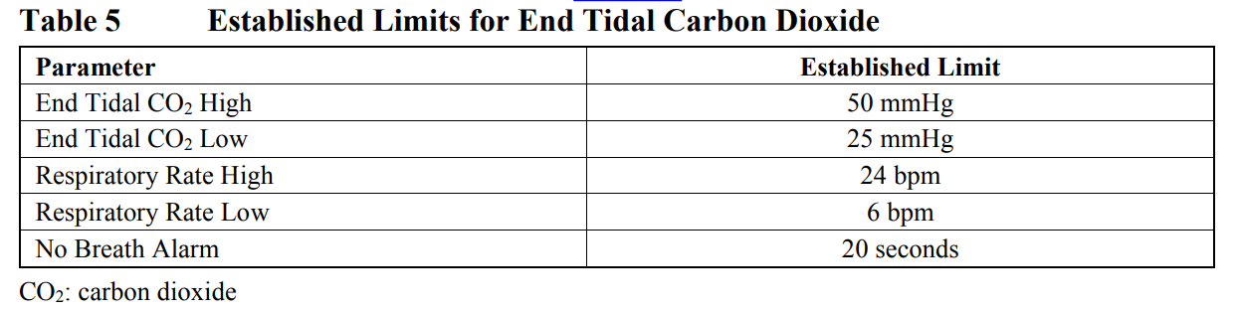

* + 1. Order of Assessments

All predose procedures, e.g., 12-lead ECG, vital signs and blood or urine sampling for clinical laboratory tests, will be performed within 60 minutes prior to dosing. All other measurements for 12-lead ECG and vital signs, will be performed within 15 minutes of the nominal time point. Pharmacokinetic sampling will be collected within 5 minutes from the nominal time point. When time points for procedures overlap, blood sampling for pharmacokinetics will be collected at the nominal time point. Blood sampling for clinical laboratory tests, 12-lead ECG, vital signs (including SpO2, if applicable), ARCI-49 and end tidal CO2 are to be collected before or after the nominal blood sampling for pharmacokinetics

* 1. Pharmacokinetics
     1. Analysis of ASP8062 and Metabolites in Plasma

Blood samples for the determination of ASP8062 and its metabolites (AS3486189, AS3486191 and AS3486192) in plasma will be collected as indicated in the Schedule of Assessments [Table 1] and Sample Collection Schedule [Table 2] for the evaluation of pharmacokinetics. If needed, other metabolites may also be measured.

Blood will be drawn in plastic tubes containing K2-EDTA. The actual date and time of each blood sample collection will be documented. Plasma will be prepared according to procedures further specified in the laboratory manual. Samples will be shipped to the designated CRO and analyzed using a validated method.

When deemed appropriate at a later date, plasma samples remaining after the pharmacokinetic analysis may be used for exploratory metabolite profiling or exploratory biomarker analysis after the study. These tests will be described in a separate report and will not be incorporated in the integrated clinical study report (CSR).

* + 1. Analysis of Morphine and Metabolites in Plasma

Blood samples for the determination of morphine and its metabolites (morphine-3β-D-glucuronide [M3G] and morphine-6β-D-glucuronide [M6G]) in plasma will be collected as indicated in the Schedule of Assessments [Table 1] and Sample Collection Schedule [Table 2] for the evaluation of pharmacokinetics. Plasma will be prepared according to procedures further specified in the laboratory manual. Samples will be shipped to the designated CRO and analyzed using a validated method.

When deemed appropriate at a later date, plasma samples remaining after the pharmacokinetic analysis may be used for exploratory metabolite profiling or exploratory biomarker analysis after the study. These tests will be described in a separate report and will not be incorporated in the integrated CSR.

* 1. Biomarkers
     1. Genetics and Pharmacogenomics

Pharmacogenomic (PGx) research may be conducted in the future to analyze or determine genes of relevance to clinical response, pharmacokinetics, toxicity/safety. A 4 mL sample of whole blood for possible banked PGx analysis will be collected as indicated in the Schedule of Assessments [Table 1]. Samples will be shipped to a sponsor-designated sample banking CRO.

Details on sample collection, labeling, storage and shipment procedures will be provided in a separate laboratory manual.

See [Section 10.7 Appendix 7: Pharmacogenomic Analysis with Banked Sample] for further details on the banking procedures.

* + 1. Pharmacodynamic Biomarkers

Not applicable.

* + 1. Other Biomarkers

Knowledge of polymorphisms of genes GABAB receptors and/or opioid receptors may help understand/explain observed differences in efficacy/safety of ASP8062. A 2 mL whole blood sample for the analysis of these biomarker (genes) will be collected as indicated in the Schedule of Assessments [Table 1].

For detailed sample collection, sample labeling and sample shipment procedures refer to the laboratory manual. All samples will be transferred to the central laboratory and then shipped to the analytical laboratory where they will be analyzed using appropriate validated methods

* 1. Immunogenicity Assessments

Not applicable.

* 1. Medical Resource Utilisation and Health Economics

Not applicable.

* 1. Total Amount of Blood

The approximate total blood volume taken per participant will be as follows:

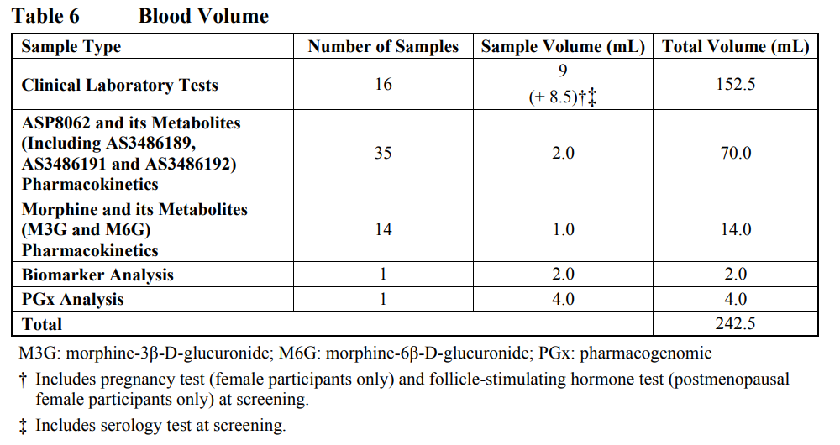

Additional blood may be drawn for safety reasons. The maximum amount of blood drawn during the study will not exceed 500 mL

1. Adverse Events, Serious Adverse Events, Product Complaints, Pregnancy and Postpartum Information
   1. Definitions
      1. Definitions of Adverse Events

An AE is any untoward medical occurrence in a patient or clinical study participant, temporally associated with the use of study IP, whether or not considered related to the study IP.

“Adverse event” means any untoward medical occurrence associated with the use of a drug in humans, whether or not considered drug related.

NOTE: an AE can therefore be any unfavorable and unintended sign (including an abnormal laboratory finding), symptom, or disease (new or exacerbated) temporally associated with the use of study IP. This includes events related to the comparator and events related to the (study) procedures.

**Events Meeting the AE Definition**

* Any abnormal laboratory test results (hematology, clinical chemistry or urinalysis) or other safety assessments (e.g., ECG, radiological scans, vital signs measurements), including those that worsen from baseline, considered clinically significant in the medical and scientific judgment of the investigator (i.e., not related to progression of underlying disease)
* Exacerbation of a chronic or intermittent pre-existing condition including either an increase in frequency and/or intensity of the condition
* New conditions detected or diagnosed after study IP administration even though it may have been present before the start of the study

**Events NOT Meeting the AE Definition**

* Any clinically significant abnormal laboratory findings or other abnormal safety assessments which are associated with the underlying disease, unless judged by the investigator to be more severe than expected for the participant’s condition
* The disease/disorder being studied or expected progression, signs, or symptoms of the disease/disorder being studied, unless more severe than expected for the participant’s condition
* Medical or surgical procedure (e.g., endoscopy, appendectomy): the condition that leads to the procedure is the AE
* Situations in which an untoward medical occurrence did not occur (social and/or convenience admission to a hospital)
* Anticipated day-to-day fluctuations of pre-existing disease(s) or condition(s) present or detected at the start of the study that do not worse
  + 1. Definitions of Serious Adverse Events

An SAE is defined as any untoward medical occurrence that, at any dose:

* Results in death
* Is life-threatening
  + The term “life-threatening” in the definition of “serious” refers to an event in which the participant was at risk of death at the time of the event. It does not refer to an event, which hypothetically might have caused death, if it were more severe.
* Requires inpatient hospitalization or prolongation of existing hospitalization
  + In general, hospitalization signifies that the participant has been detained (usually involving at least an overnight stay) at the hospital or emergency ward for observation and/or treatment that would not have been appropriate in the physician’s office or outpatient setting. Complications that occur during hospitalization are AEs. If a complication prolongs hospitalization or fulfills any other serious criteria, the event is serious. When in doubt as to whether “hospitalization” occurred or was necessary, the AE should be considered serious.
  + Hospitalization for elective treatment of a pre-existing condition that did not worsen from baseline is not considered an AE.
* Results in persistent or significant disability/incapacity
  + The term disability means a substantial disruption of a person’s ability to conduct normal life functions.
  + This definition is not intended to include experiences of relatively minor medical significance such as uncomplicated headache, nausea, vomiting, diarrhea, influenza, and accidental trauma (e.g., sprained ankle), which may interfere with or prevent everyday life functions but do not constitute a substantial disruption.
* Is a congenital anomaly/birth defect
* Other situations:
  + Medical or scientific judgment should be exercised in deciding whether SAE reporting is appropriate in other situations such as important medical events that may not be immediately life-threatening or result in death or hospitalization but may jeopardize the participant or may require medical or surgical intervention to prevent one of the other outcomes listed in the above definition. These events should usually be considered serious.
  + Examples of such events include invasive or malignant cancers, intensive treatment in an emergency room or at home for allergic bronchospasm, blood dyscrasias or convulsions that do not result in hospitalization, or development of drug dependency or drug abuse.

If an event is not an AE per definition in [Section 10.3.1 Appendix 3 Definition of Adverse Events], then it cannot be an SAE even if serious conditions are met (e.g., hospitalization for signs/symptoms of the disease under study, death due to progression of disease).

* 1. Timing and Mechanism for Collection and Reporting

All SAEs will be collected from the signing of the ICF until the follow-up visit at the time points specified in the Schedule of Assessments [Table 1] and reported on the electronic data source.

All AEs will be collected from the signing of the ICF until the follow-up visit at the time points specified in the Schedule of Assessments [Table 1] and reported on the electronic data source.

If the severity of an AE/SAE changes, the event should be relisted on the electronic data source with the new severity and new onset date.

If the severity decreases, the AE/SAE should be relisted on the electronic data source with the new severity and new onset date. The exception is ongoing predose events that continue postdose and improve postdose. Such events should not be relisted.

If the severity of an SAE reduces, the details of the AE should be provided on the SAE worksheet for the medical assessor to be able to assess the course of the event.

All SAEs will be recorded and reported to the sponsor or designee immediately and under no circumstance should this exceed 24 hours, as indicated in [Section 10.3 Appendix 3: Adverse Events: Definitions and Procedures for Recording, Evaluating, Follow-up and Reporting]. The investigator will submit any updated SAE data to the sponsor within 24 hours of it being available.

Investigators are not obligated to actively seek AE or SAE after conclusion of the study participation. However, if the investigator learns of any SAE, including a death, at any time after a participant has been discharged from the study, and he/she considers the event to be reasonably related to the study IP or study participation, the investigator must promptly notify the sponsor.

* 1. Identification, Recording and Follow-Up

AEs will be reported by the participant (or, when appropriate, by a caregiver, surrogate, or the participant’s legally authorized representative).

The investigator and any qualified designees are responsible for detecting, documenting and recording events that meet the definition of an AE or SAE and remain responsible for following up AEs that are serious, considered related to the study IP, or that caused the participant to discontinue the IP and/or study [Section 10.3 Appendix 3 Adverse Events: Definitions and Procedures for Recording, Evaluating, Follow-up and Reporting].

The method of recording, evaluating, and assessing causality of AE and SAE and the procedures for completing and transmitting SAE reports are provided in [Section 10.3 Appendix 3: Adverse Events: Definitions and Procedures for Recording, Evaluating, Follow-up and Reporting].

**AE and SAE Recording**

* When an AE/SAE occurs, it is the responsibility of the investigator to review all documentation (e.g., hospital progress notes, laboratory reports, and diagnostics reports) related to the event.
* The investigator will then record all relevant AE/SAE information in the electronic data source.
* It is not acceptable for the investigator to send photocopies of the participant’s medical records to the sponsor in lieu of completion of the electronic data source.
* There may be instances when copies of medical records for certain cases are requested by the sponsor. In this case, all participant identifiers, with the exception of the participant number, will be redacted on the copies of the medical records before submission to the sponsor.
* The investigator will attempt to establish a diagnosis of the event based on signs, symptoms, and/or other clinical information. Whenever possible, the diagnosis (not the individual signs/symptoms) will be documented as the AE/SAE.
  + 1. Identification

Care will be taken not to introduce bias when detecting AEs and/or SAEs. Open-ended and nonleading verbal questioning of the participant is the preferred method to inquire about AE occurrence.

* + 1. Severity

The investigator will use the following definitions to rate the severity of each AE:

* Mild: No disruption of normal daily activities
* Moderate: Affect normal daily activities
* Severe: Inability to perform daily activities.

* + 1. Causality
* The investigator is obligated to assess the relationship between study IP and each occurrence of each AE/SAE.
* A “reasonable possibility” of a relationship conveys that there are facts, evidence and/or arguments to suggest a causal relationship, rather than a relationship cannot be ruled out.
* The investigator will use clinical judgment to determine the relationship.
* Alternative causes, such as underlying disease(s), concomitant therapy and other risk factors, as well as the temporal relationship of the event to study IP administration will be considered and investigated.
* The investigator will also consult the Investigator’s Brochure and/or Product Information, for marketed products, in his/her assessment.
* For each AE/SAE, the investigator must document in the medical notes that he/she has reviewed the AE/SAE and has provided an assessment of causality.
* There may be situations in which an SAE has occurred and the investigator has minimal information to include in the initial report to the sponsor. However, it is very important that the investigator always make an assessment of causality for every event before the initial transmission of the SAE data to the sponsor.
* The investigator may change his/her opinion of causality in light of follow-up information and send an SAE follow-up report with the updated causality assessment.
* The causality assessment is one of the criteria used when determining regulatory reporting requirements.

Following a review of the relevant data, the causal relationship between the IP and each (S)AE will be assessed by answering “yes” or “no” to the question “Do you consider that there is a reasonable possibility that the event may have been caused by the IP?”

When making an assessment of causality, the following factors are to be considered when deciding if there is evidence and/or arguments to suggest there is a “reasonable possibility” that an (S)AE may have been caused by the IP (rather than a relationship cannot be ruled out) or if there is evidence to reasonably deny a causal relationship:

* Has the participant been administered IP?
* Plausibility (i.e., could the event have been caused by the suspect IP? Consider biologic and/or pharmacologic mechanism, half-life, literature evidence, drug class, preclinical and study data, etc.)
* Dechallenge/dose reduction/rechallenge:
  + Dechallenge: did the (S)AE resolve or improve after only stopping the dose of the suspect drug without any treatment?
  + Dose reduction: did the (S)AE resolve or improve after reducing the dose of the suspect drug?
  + Rechallenge: did the (S)AE reoccur if the suspected drug was reintroduced after having been stopped?
* Laboratory or other test results: a specific laboratory investigation supports the assessment of the relationship between the (S)AE and the IP (e.g., based on values pre-, during and post-treatment)
* Available alternative explanations independent of IP exposure; such as other concomitant drugs, past medical history, concurrent or underlying disease, risk factors including medical and family history, season, location, etc., and strength of the alternative explanation
* Temporal relationship between exposure to the IP and (S)AE onset and/or resolution. Did the (S)AE occur in a reasonable temporal relationship to the administration of the IP?
* Finally, judging which are more likely based on all the above contents, factors of reasonable possibility or confounding factors, comprehensive judgment of plausible will be provided.

There may be situations in which an SAE has occurred and the investigator has minimal information to include in the initial report to the sponsor. While it is very important that the investigator always assesses causality for every event before the initial transmission of the SAE data to the sponsor, the initial report should be submitted without delay (i.e., within 24 hours of awareness). With limited or insufficient information about the event to make an informed medical judgment and in absence of any indication or evidence to establish a causal relationship, a causality assessment of “no” is to be considered. In such instance, the investigator is expected to obtain additional information regarding the event as soon as possible and to re-evaluate the causality upon receipt of additional information. The medically qualified investigator may revise his/her assessment of causality in light of new information regarding the SAE and shall send an SAE follow-up report and update the electronic data source with the new information and updated causality assessment.

* + 1. Follow-up

After the initial AE/SAE report, the investigator is required to proactively follow each participant at subsequent visits/contacts. All SAEs and AEs of special interest (as defined in [Section 7.3.6 Adverse Events of Special Interest]) will be followed until resolution, stabilization, the event is otherwise explained, or the participant is lost to follow-up (as defined in [Section 8.3 Lost to Follow-up]). Further information on follow-up procedures is provided in [Section 10.3 Appendix 3: Adverse Events: Definitions and Procedures for Recording, Evaluating, Follow-up and Reporting].

If after the protocol-defined AE collection period (see [Section 7.3.1 Time Period and Frequency for Collecting Adverse Event and Serious Adverse Event Information]), an AE progresses to an SAE, or the investigator learns of any (S)AE (serious adverse event or adverse event) including death, where he/she considers there is reasonable possibility it is related to the IP or study participation, the investigator must promptly notify the sponsor.

**Follow-up of AEs and SAEs**

* The investigator is obligated to perform or arrange for the conduct of supplemental measurements and/or evaluations as medically indicated or as requested by the sponsor to elucidate the nature and/or causality of the AE or SAE as fully as possible. This may include additional laboratory tests or investigations, histopathological examinations or consultation with other health care professionals.
* New or updated information will be recorded in the originally completed electronic data source.
* The investigator will submit any updated SAE data to the sponsor within 24 hours of receipt of the information
  1. Reporting

The investigator must complete and submit an SAE worksheet containing all information that is required by local and/or regional regulations to the sponsor by fax or email immediately (within 24 hours of awareness).

The SAE worksheet must be signed by a medically qualified investigator (as identified on delegation of authority log). Signature confirms accuracy and completeness of the SAE data, as well as the investigator causality assessment including the explanation for the causality assessment.

If the SAE is associated with emergency unblinding by the investigator as outlined in [Section 6.3.4 Breaking the Treatment Code for Emergency], this is to be recorded on the SAE worksheet. On the SAE worksheet, the investigator is to include when unblinding took place in association with the SAE.

For contact details, see [Contact Details of Sponsor’s Key Personnel]. Fax or email the SAE/special situations/product defect worksheet to:

Astellas Pharma Global Development Inc.

US Pharmacovigilance

North America fax number: +1-888-396-3750

North America alternate fax number: +1-847-317-1241

Email: [safety-us@astellas.com](mailto:safety-us@astellas.com)

If there are any questions, or if clarification is needed regarding the SAE, please contact the sponsor’s medical monitor/study physician or their designee [Contact Details of Sponsor’s Key Personnel].

Follow-up information for the event should be sent promptly (as soon as available but no longer than within 7 days of the initial notification).

Full details of the SAE should be recorded on the medical records, SAE/special situation worksheet and on the electronic data source.

The following minimum information is **required**:

* International study number/study number
* Participant number, sex and age
* Date of report
* Description of the SAE (event and seriousness criteria)
* Causal relationship to the IP (including reason)
* Drug provided (if any)

The sponsor or sponsor’s designee will medically evaluate the SAE and determine if the report meets the requirements for expedited reporting based on seriousness, causality and expectedness of the events (e.g., SUSAR reporting) according to current local/regional regulatory requirements. The sponsor or sponsor’s designee will submit expedited safety reports to competent authorities and concerned ethics committee per current local regulations and will inform the investigators of such regulatory reports as required. Investigators must submit safety reports as required by their IRB/IEC within timelines set by regional regulations (e.g., EMA, FDA) where required. Documentation of the submission to and receipt by the IRB/IEC of expedited safety reports should be retained by the study site. In the US, FDA expedited IND reporting guidelines will be followed.

The sponsor will notify all investigators responsible for ongoing clinical studies with the test product of all SUSARs, which require submission per local requirements IRB/IEC.

The heads of the study sites/investigators should provide written documentation of IRB/IEC notification for each report to the sponsor.

The investigator may contact the sponsor’s medical monitor/study physician for any other problem related to the rights, safety or well-being of the participant

* + 1. Regulatory Reporting Requirements
* Prompt notification by the investigator to the sponsor of an SAE is essential so that legal obligations and ethical responsibilities towards the safety of participants and the safety of a study IP under clinical investigation are met.
* The sponsor has a legal responsibility to notify both the local regulatory authority and other regulatory agencies about the safety of a study IP under clinical investigation. The sponsor will comply with country-specific regulatory requirements relating to safety reporting to the regulatory authority, IRB/IEC and investigators.
* Investigator safety reports must be prepared for SUSAR according to local regulatory requirements and sponsor policy and forwarded to investigators as necessary.
* An investigator who receives an investigator safety report describing an SAE or other specific safety information (e.g., summary or listing of SAEs) from the sponsor will review and then file it along with the Investigator’s Brochure and will notify the IRB/IEC, if appropriate according to local requirements.
  + 1. Adverse Events of Special Interest

AEs of special interest are AEs the sponsor may wish to carefully monitor. These AEs may be serious or nonserious and should be reported on the electronic data source and the SAE worksheet. These AEs are not considered SAEs unless they meet the definition of an SAE.

AEs related to potential substance abuse and suicide (serious or nonserious) are considered to be of scientific and medical concern specific to ASP8062, for which ongoing monitoring and reporting is required.

Additional information around AEs of special interest will be collected to complete participant narratives. AEs of special interest related to potential substance abuse are listed in [Section 10.10 Appendix 10 Adverse Events of Interest Related to Potential Substance Abuse and Following Drug Withdrawal].

AEs of special interest with respect to morphine include respiratory depression, constipation, nausea, vomiting, sedation, somnolence, lightheadedness, dizziness, and sweating.

*See Section 12.8*

* + 1. Disease-related Events or Outcomes Not Qualifying as AEs or SAEs

Not applicable.

* + 1. Special Situations

Certain special situations observed in association with the IP, such as incorrect administration (e.g., wrong dose of IP or background therapy) are reported as protocol deviations and/or may require special reporting, as described below. These special situations are not considered AEs, but do require to be communicated to Astellas as per the timelines defined below.

If a special situation is associated with, or results in, an AE, the AE is to be assessed separately from the special situation and captured as an AE in the electronic data source. If the AE meets the definition of an SAE, the SAE is to be reported as described in [Section 10.3.7 Appendix 3 Reporting Procedures for Serious Adverse Events] and the details of the associated special situation are to be included in the clinical description on the special situation worksheet or pregnancy reporting form.

The special situations are:

* Pregnancy
* Lactation
* Medication error, overdose and “off-label use”
* Misuse/abuse
* Occupational exposure
* Suspected DDI Instructions and procedures for reporting special situations are provided in [Section 10.3.8 Appendix 3 Reporting Procedures for Special Situations]
  + - 1. Medication Error, Overdose and “Off-label Use”

If a medication error (defined as an unintended failure in the treatment process that leads to, or has the potential to lead to, harm to the participant), overdose or “off-label use” (i.e., use outside of the target disease defined in the protocol) is suspected, refer to [Section 6.7 Treatment of Overdose]. Any associated (S)AEs are to be reported in the electronic data source. If the AE meets the definition of an SAE, the SAE is also to be reported as described in [Section 10.3.7 Appendix 3 Reporting Procedures for Serious Adverse Events] together with the details of the medication error, overdose and/or “off-label use.”

* + - 1. Misuse/Abuse

Definition of misuse: situations where the IP is/are intentionally and inappropriately used not in accordance with the intended use as defined in the protocol.

Definition of abuse: persistent or sporadic, intentional excessive use of medicinal products which is accompanied by harmful physical or psychological effects.

If misuse or abuse of the IP is suspected, the investigator must forward the special situation worksheet to the sponsor by fax or email immediately (within 24 hours of awareness). Any associated (S)AEs are to be reported in the electronic data source. If the AE meets the definition of an SAE, the SAE is also to be reported as described in [Section 10.3.7 Appendix 3 Reporting Procedures for Serious Adverse Events] together with details of the misuse or abuse of the IP.

* + - 1. Occupational Exposure

If occupational exposure (e.g., inadvertent exposure to the IP of study site personnel while preparing it for administration to the participant) to the IP occurs, the investigator must forward the special situation worksheet to the sponsor by fax or email immediately (within 24 hours of awareness). Any associated (S)AEs occurring to the individual associated with or resulting from the special situation are to be reported on the special situations worksheet.

* + - 1. Suspected Drug-drug Interaction

If a DDI associated with the IP is suspected, the investigator must forward the special situation worksheet to the sponsor by fax or email immediately (within 24 hours of awareness). Any associated (S)AEs are to be reported in the electronic data source. If the AE meets the definition of an SAE, the SAE is also to be reported as described in [Section 10.3.7 Appendix 3 Reporting Procedures for Serious Adverse Events] together with details of the suspected DDI.

* + 1. Abnormal Laboratory Findings

Any abnormal laboratory test result (e.g., hematology, biochemistry or urinalysis) or other safety assessment (e.g., vital signs, physical examination or ECGs), including those that worsen from baseline, that is considered to be clinically significant in the medical and scientific judgment of the investigator and not related to underlying disease, is to be reported as an (S)AE.

Any clinically significant abnormal laboratory finding or other abnormal safety assessment, which is associated with the underlying disease, does not require reporting as an (S)AE, unless judged by the investigator to be more severe than expected for the participant’s condition.

Repeating an abnormal laboratory test or other safety assessment, in the absence of any of the above criteria, does not constitute an AE. Any abnormal test result that is determined to be an error does not require reporting as an AE.

* + - 1. Potential Cases of Drug-induced Liver Injury

Refer to [Section 10.4 Appendix 4: Liver Safety Monitoring and Assessment] for detailed instructions on drug-induced liver injury. Abnormal values in AST and/or ALT concurrent or with abnormal elevations in TBL that meet the criteria outlined in [Section 10.4 Appendix 4: Liver Safety Monitoring and Assessment], in the absence of other causes of liver injury, are considered potential cases of drug-induced liver injury (potential Hy’s Law cases) and are always to be considered important medical events and reported per [Section 10.3.7 Appendix 3 Reporting Procedures for Serious Adverse Events].

* 1. Pregnancy and Postpartum Information
     1. Participants Who Become Pregnant During the Trial

If a female participant becomes pregnant during the study dosing period or within 28 days from the discontinuation of dosing, the investigator is to report the information to the sponsor according to the timelines in [Section 10.3.7 Appendix 3 Reporting Procedures for Serious Adverse Events] using the SAE worksheet as a special situation and in the electronic data source.

The investigator will attempt to collect pregnancy information on any female partner of a male participant who becomes pregnant during the study dosing period or within 90 days from the discontinuation of dosing and report the information to the sponsor according to the timelines in [Section 10.3.7 Appendix 3 Reporting Procedures for Serious Adverse Events] using the special situation worksheet or pregnancy form.

The expected date of delivery or expected date of the end of the pregnancy, last menstruation, estimated conception date, pregnancy result and neonatal data, etc., should be included in this information.

While pregnancy itself is not considered to be an AE or SAE, any pregnancy complication or termination (including elective termination) of a pregnancy is to be reported for a female participant as an AE in the electronic data source or SAE per [Section 10.3.7 Appendix 3 Reporting Procedures for Serious Adverse Events]. Participant pregnancy outcomes listed below are to be reported as SAEs:

* Spontaneous abortion/miscarriage, abortion and missed abortion
* Death of a newborn or infant within 1 month after birth is to be reported as an SAE regardless of its relationship with the IP
* If an infant dies more than 1 month after the birth, it is to be reported if a relationship between the death and intrauterine exposure to the IP is judged as “possible” by the investigator
* Congenital anomaly (including anomaly in miscarried fetus)
* Benign hydatidiform mole
* Blighted ovum

Unless a congenital anomaly is identified prior to spontaneous abortion or miscarriage, the embryo or fetus should be assessed for congenital defects by visual examination or other means as appropriate. (S)AEs experienced by the newborn/infant should be reported via the pregnancy reporting form. Generally, follow-up will be no longer than 6 to 8 weeks following the estimated delivery date.

1. Statistical Considerations
   1. General Considerations

In general, data will be summarized with descriptive statistics for continuous endpoints, and frequency and percentage for categorical endpoints, unless otherwise specified. Percentages by categories will be based on the number of participants with no missing data (i.e., will add up to 100%).

Baseline will be defined as the last nonmissing observation prior to first administration of IP, unless otherwise specified.

Demographics and baseline characteristics (age, sex, race, ethnicity, body weight, height and BMI) will be summarized by treatment group and overall for all randomized participants.

The number and percentage of participants who completed and discontinued treatment and reasons for treatment discontinuation will be presented for all randomized participants and for participants in the safety analysis set (SAF) by treatment group (ASP8062 alone, placebo alone, morphine in combination with ASP8062, morphine in combination with placebo) and overall. Similar tables for screening disposition, investigational period disposition and follow-up disposition will also be presented for all randomized participants by treatment group (ASP8062 alone, placebo alone, morphine in combination with ASP8062, morphine in combination with placebo) and overall. All disposition details and dates of first and last evaluations for each participant will be listed.

Previous and concomitant treatment (medication and nonmedication therapy) and medical history will be listed. The number and percentage of participants exposed to IP will be summarized by treatment group (ASP8062 alone, placebo alone, morphine in combination with ASP8062, morphine in combination with placebo) and visit. All IP exposure data will be listed.

* 1. Analysis Sets

For each treatment group, the number and percentage of participants will be characterized for all randomized participants and by each population. The following populations are defined:

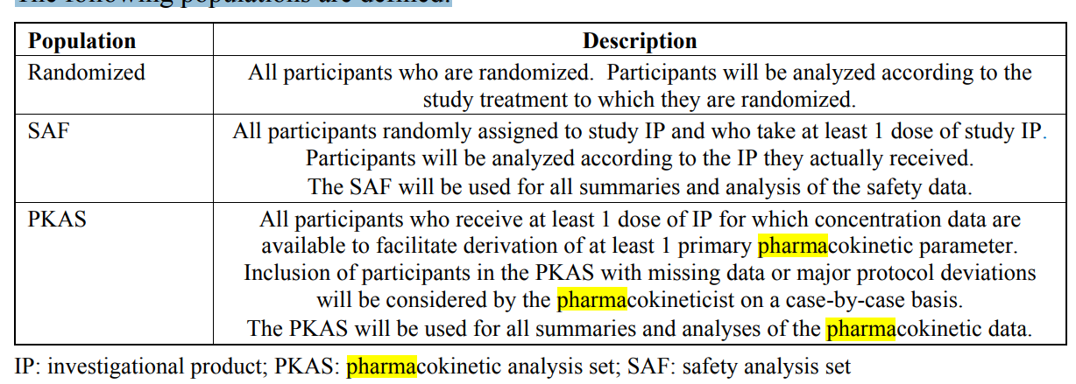

* 1. Analyses of Demographics and Other Baseline Variables

Not applicable.

* 1. Analyses Associated with the Primary Objective(s)
     1. Statistical Method of Analysis

For analysis of safety, the treatment groups are (ASP8062 alone, placebo alone, morphine in combination with ASP8062, morphine in combination with placebo).

* + - 1. Adverse Events

AEs will be coded using MedDRA. An AE with onset at any time from first dosing until last scheduled procedure will be classified as a treatment-emergent adverse event (TEAE) for inclusion in the summary tabulations. An IP-related TEAE is defined as any TEAE with a causal relationship assessed as “yes” by the investigator, or records where the relationship is missing.

An overview and separate summaries of the number and percentage of participants with TEAEs, IP-related TEAEs, TEAEs leading to withdrawal of treatment, IP-related TEAEs leading to withdrawal of treatment and TEAEs excluding SAEs that equal or exceed a threshold of 5% in any treatment group will be presented by SOC, preferred term and treatment group. Also included in the overview are the number and percentage of participants with serious TEAEs, IP-related serious TEAEs, TEAEs leading to death and IP-related TEAEs leading to death.

The number and percentage of participants who have a TEAE within the drug abuse dependence Standardized MedDRA Queries (SMQ) (MedDRA v22.0) as classified by SOC and preferred term, will be summarized by treatment group. In addition, the number and percentage of participants who have drug abuse-related TEAEs as classified by preferred term and lowest level term will be summarized by treatment group [Section 10.10 Appendix 10 Adverse Events of Interest Related to Potential Substance Abuse and Following Drug Withdrawal].

The number and percentage of participants who have a TEAE with the drug withdrawal SMQ (MedDRA v22.0) as classified by SOC and preferred term will be summarized by treatment group. In addition, the number and percentages of participants who have withdrawal-related TEAEs as classified by SOC and preferred term will be summarized by treatment group [Section 10.10 Appendix 10 Adverse Events of Interest Related to Potential Substance Abuse and Following Drug Withdrawal].

AE data will be listed.

* + - 1. Laboratory Assessments

For quantitative clinical laboratory measurements (hematology and biochemistry), descriptive statistics will be used to summarize results and change from baseline by treatment group and time point.

The number and percentage of participants with potentially clinically significant values in liver enzymes and TBL will be tabulated.

Laboratory data will be listed.

* + - 1. Vital Signs

Descriptive statistics will be used to summarize vital sign results (blood pressure, pulse and respiratory rate) and changes from baseline for participants in the SAF by treatment group and time point.

The number and percentage of participants with respiratory rate values as per [Table 7] at any time point will be summarized by treatment group. The lowest and highest respiratory rate, respectively, will be used in the analysis.

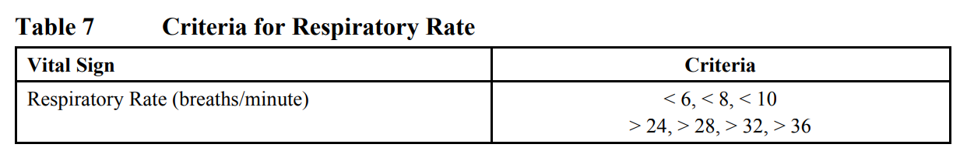

The number and percentage of participants who reach an alarm value for the continuous respiratory rate, and the number of times an alarm value was reached will be listed and summarized by treatment.

Vital signs data will be listed.

* + - 1. Continuous Pulse Oximetry and Spot Blood Oxygen Saturation

The spot SpO2 levels and change from baseline (day 1) will be listed and summarized by treatment group and time point. The number and percentage of participants with SpO2 levels as per [Table 8] at any time point will be summarized by treatment group. The lowest SpO2 level across the time points will be used in the analysis.

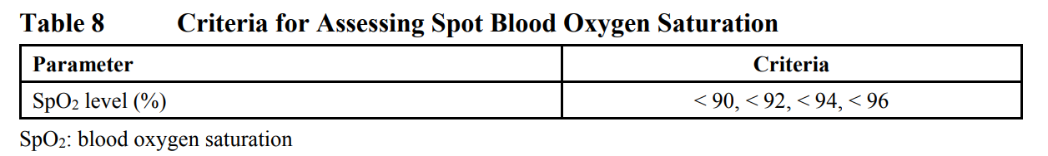

The number and percentage of participants who reach an alarm value of continuous pulse oximetry, and the number of times an alarm value was reached will be listed and summarized by treatment.

* + - 1. 12-lead Electrocardiogram

The number and percentage of participants with 12-lead ECG criteria as per [Table 9] will be provided by treatment group, at each time point and overall by visit.

The average of the triplicate ECG measurements will be used for the analysis.

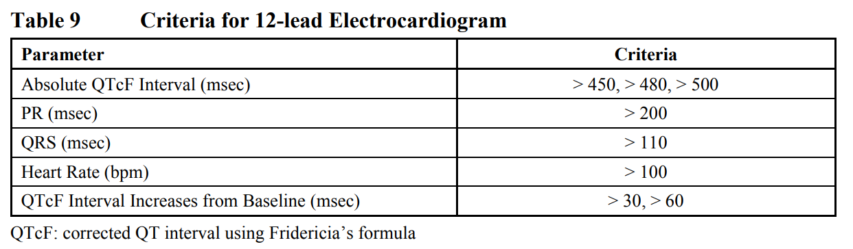

12-lead ECG data and interpretations will be listed.

* + - 1. Columbia-Suicide Severity Rating Scale

The listings will include only C-SSRS assessments that show at least 1 event of suicidality (suicidal ideation and/or suicidal behavior).

* + - 1. 49-item Short Form of Addiction Research Center Inventory Scale

From the completed ARCI-49 questionnaire, scores for the amphetamine, benzedrine, pentobarbital-chlorpromazine-alcohol, morphine-benzedrine and lysergic-acid-diethylamide groups will be calculated. The calculated subscale score and change from baseline will be listed and summarized by treatment group and time point.

The algorithm for scoring the ARCI-49 [Martin et al, 1971] is presented in [Section 10.9 Appendix 9 49-item Short Form of Addiction Research Center Inventory Scale, Questionnaire Scoring]. One point will be given for each response that agrees with the scoring direction. Specifically, 1 point will be given for each “true” response (i.e., item has associated scoring coefficient +1), and 1 point will be given for each “false” response in the reverse-scored items (i.e., item has associated scoring coefficient -1). Each subscale score will be derived as the linear combination (sum) of mathematically-signed points among the relevant items, i.e., matched true/false responses. Some items belong to more than 1 subscale.

No missing data will be imputed.

* + - 1. Continuous and Spot End Tidal Carbon Dioxide

The spot end tidal CO2 levels and change from baseline (day 9) will be listed and summarized by treatment group and time point. The number and percentage of participants with end tidal CO2 levels as per [Table 10] at any time point will be summarized by treatment group. The lowest and the highest end tidal CO2 level, respectively, will be used in the analysis.

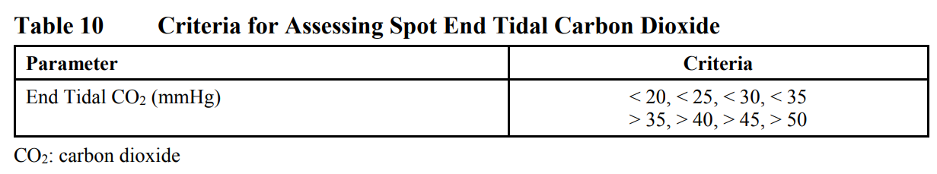

The number and percentage of participants who reach an alarm value of continuous end tidal CO2, and the number of times an alarm value was reached will be listed and summarized by treatment.

* + 1. Handling of Data in Relation to Primary Estimand(s)

Not applicable.

* + 1. Handling of Missing Data

As a general principle, no imputation of missing data will be done. Exceptions are the start and stop dates of AEs and concomitant medications if they are missing on day of first IP administration. The imputed dates will be used to assess if the AEs or concomitant medications are treatment-emergent or concomitant, respectively. Listings of the AEs and concomitant medications will present the actual partial dates; imputed dates will not be shown.

* 1. Analysis Associated with the Secondary Objective(s)
     1. Statistical Method of Analysis

**Analysis of Pharmacokinetics**

Descriptive statistics will include n, mean, SD, minimum, median, maximum, CV, geometric mean and geometric CV. For the pharmacokinetic parameters tmax and tlag, only n, median, minimum and maximum will be calculated.

* + - 1. Pharmacokinetic Concentrations

Descriptive statistics will be presented for plasma concentrations of morphine and its metabolites (M3G and M6G) in combination with placebo and in combination with ASP8062 by scheduled sample time. Standard graphics including mean plasma concentration-time profiles, overlay (spaghetti) plots and individual participant plasma concentration-time profiles for morphine and its metabolites (M3G and M6G) in combination with placebo and in combination with ASP8062 will be produced.

Descriptive statistics will be presented for plasma concentrations of ASP8062 and its metabolites (including AS3486189, AS3486191 and AS3486192) alone and ASP8062 in combination with morphine by scheduled sample time. Standard graphics including mean plasma concentration-time profiles, overlay (spaghetti) plots and individual participant plasma concentration-time profiles for ASP8062 and its metabolites (including AS3486189, AS3486191 and AS3486192) alone and ASP8062 in combination with morphine will be produced.

* + - 1. Estimation of Pharmacokinetic Parameters

Noncompartmental analysis will be used for the calculation of plasma pharmacokinetic parameters using Phoenix version 6.3 or higher (Certara LP, 100 Overlook Center, Suite 101, Princeton, NJ 08540, US).

Plasma pharmacokinetic parameters of morphine and its metabolites (M3G and M6G) in combination with placebo and in combination with ASP8062 will be listed and summarized using descriptive statistics.

Plasma pharmacokinetic parameters of ASP8062 and its metabolites (including AS3486189, AS3486191 and AS3486192) alone and ASP8062 in combination with morphine will be listed and summarized using descriptive statistics.

* + - 1. Statistical Analysis of Pharmacokinetic Parameters

To assess the effect of morphine on the pharmacokinetics of ASP8062 and its metabolites (AS3486189, AS3486191 and AS3486192), an analysis of variance (ANOVA) model with treatment (ASP8062 in combination with morphine and ASP8062 alone) as a fixed effect and participants as a random effect will be fitted on natural logarithmic-transformed AUC24 and Cmax. Within the ANOVA, the least squares (LS) mean differences between ASP8062 in combination with morphine and ASP8062 alone, along with 90% CIs for the differences will be estimated. The LS means for AUC24 and Cmax will be back-transformed to produce the geometric LS means and presented with the number of participants for each treatment. The geometric LS mean ratios and their corresponding 90% CIs for each pharmacokinetic parameter will be presented by back-transforming and expressed as percentages.

To assess the effect of ASP8062 on the pharmacokinetics of morphine and its metabolites (M3G and M6G), similar analysis will be done with treatment (morphine in combination with ASP8062 and morphine in combination with placebo) as a fixed effect and participant as a random effect.

If all participants did not complete treatment, then the above analyses will be repeated using an ANOVA with fixed effects for treatment and participant; this analysis will only include participants with complete data in all treatments.

* + 1. Handling of Missing Data

See above.

* 1. Analysis Associated with the Exploratory Objective(s)

Not applicable.

* 1. Safety Analyses

See above.

* 1. Other Analyses

Select polymorphisms of genes GABAB receptor and/or opioid receptors will be summarized and listed. In addition, polymorphisms of genes may be summarized graphically or descriptively as they relate to clinical measures, as applicable. All analyses described in this section are based on availability of data.

* 1. Interim Analyses

Not applicable.

* 1. Multiplicity Adjustments

Not applicable.

* 1. Sample Size Determination

Approximately 24 participants will be enrolled to complete at least 18 participants. Participants who discontinue early from the study may be replaced at the discretion of the sponsor. No formal sample size calculation is performed as this is not a statistically powered study. The number of participants is based on the precedent set by other studies of similar nature. The number of participants planned is considered sufficient to achieve the study objectives.

Based on data from Study 8062-CL-0005, the intrasubject coefficient of variation (CV) for pharmacokinetic parameters AUCinf and Cmax of ASP8062 are estimated to be between 10% and 24%. Based on the literature, the intrasubject CV for pharmacokinetic parameter Cmax of morphine is estimated to be 27% [Center for Drug Evaluation and Research, 2008].

Assuming the underlying variability is similar to 27% and the true underlying ratio is 100%, the 90% CI will lie within (76, 131) with > 80% probability.

1. Trial Oversight and Other General Considerations
   1. Regulatory and Ethical Considerations

This study will be conducted in accordance with the protocol and with the following:

* Consensus ethical principles derived from international guidelines including the Declaration of Helsinki and Council for International Organizations of Medical Sciences International Ethical Guidelines
* Applicable ICH GCP Guidelines
* Applicable laws and regulations

The protocol, protocol amendments, ICF, Investigator’s Brochure, and other relevant documents (e.g., advertisements) must be submitted to an IRB/IEC by the investigator and reviewed and approved by the IRB/IEC before the study is initiated.

Any amendments to the protocol will require IRB/IEC approval before implementation of changes made to the study design, except for changes necessary to eliminate an immediate hazard to study participants.

The investigator will be responsible for the following:

* Providing written summaries of the status of the study to the IRB/IEC annually or more frequently in accordance with the requirements, policies, and procedures established by the IRB/IEC
* Notifying the IRB/IEC of SAEs or other significant safety findings as required by IRB/IEC procedures
* Providing oversight of the conduct of the study at the site and adherence to requirements of 21 CFR, ICH guidelines, the IRB/IEC, European regulation 536/2014 for clinical studies (if applicable), and all other applicable local regulations.
  1. Trial Oversight
     1. Investigator Responsibilities
        1. Financial Disclosure

Investigators and subinvestigators will provide the sponsor with sufficient, accurate financial information as requested to allow the sponsor to submit complete and accurate financial certification or disclosure statements to the appropriate regulatory authorities. Investigators are responsible for providing information on financial interests during the course of the study and for 1 year after completion of the study.

* + - 1. Supply of New Information Affecting the Conduct of the Study

When new information becomes available that is necessary for conducting the study properly, the sponsor will inform all investigators involved in the study as well as the appropriate regulatory authorities. Investigators should inform the IRB/IEC of such information when needed.

The investigator will also inform the participants, who will be required to sign an updated ICF in order to continue in the study.

* + - 1. Urgent Safety Measures

An urgent safety measure (USM) is an intervention that is not defined by the protocol and can be put in place with immediate effect without needing to gain prior approval by the sponsor, relevant competent authorities, IRB/IEC, where applicable, in order to protect participants from any immediate hazard to their health and/or safety. Either the investigator or the sponsor can initiate a USM. The cause of a USM can be safety-, product- or procedure-related. 10.3.11 Reporting Urgent Safety Measures In the event of a potential USM, the investigator must contact the study physician (within 24 hours of awareness). Full details of the potential USM are to be recorded in the participant’s medical records. The sponsor may request additional information related to the event to support their evaluation.

If the event is confirmed to be a USM, the sponsor will take appropriate action to ensure the safety and welfare of the participants. These actions may include but are not limited to a change in study procedures or study treatment, halting further enrollment in the study or stopping the study in its entirety. The sponsor or sponsor’s designee will notify the relevant competent authorities and concerned ethics committee within the timelines required per current local regulations and will inform the investigators, as required. When required, investigators must notify their IRB/IEC within timelines set by regional regulations.

* + 1. Sponsor Responsibilities

When new information becomes available that is necessary for conducting the study properly, the sponsor will inform all investigators involved in the study as well as the appropriate regulatory authorities. Investigators should inform the IRB/IEC of such information when needed.

* 1. Informed Consent Process
     1. Informed Consent Process

The investigator or his/her representative will explain the nature of the study to the participant and answer all questions regarding the study.

Participants must be informed that their participation is voluntary. Participants will be required to sign a statement of informed consent that meets the requirements of 21 CFR 50, local regulations, ICH guidelines, Health Insurance Portability and Accountability Act requirements, where applicable, and the IRB/IEC or study center.

The medical record must include a statement that written informed consent was obtained before the participant was enrolled in the study and the date the written consent was obtained. The authorized person obtaining the informed consent must also sign the ICF.

Participants must be reconsented to the most current version of the ICF(s) during their participation in the study.

A copy of the ICF(s) must be provided to the participant.

* + 1. Supply of New and Important Information Influencing the Participant’s Consent and Revision of the Written Information

The investigator or his/her representative will immediately inform the participant verbally whenever new information becomes available that may be relevant to the participant’s consent or may influence the participant’s willingness to continue participating in the study (e.g., report of serious adverse drug reaction). The communication must be documented in the participant’s medical records and whether the participant is willing to remain in the study or not must be confirmed and documented.

The investigator must update the participant’s ICF and submit it for approval to the IRB/IEC. The investigator or his/her representative must obtain written informed consent from the participant on all updated ICFs throughout their participation in the study. The investigator or his/her designee must reconsent participants with the updated ICF even if relevant information was provided verbally. The investigator or his/her representative who obtained the written informed consent and the participant should sign and date the ICF. A copy of the signed ICF will be given to the participant and the original will be placed in the participant’s medical record. An entry must be made in the participant’s records documenting the reconsent process.>

* 1. Committees

Not applicable.

* 1. Insurance and Indemnity

*Not available.*

* 1. Risk Management

*Not available.*

* 1. Data Governance
     1. Data Protection

Individual participant medical information obtained as a result of this study is considered confidential and disclosure to third parties is prohibited unless the participant provides written consent or approval. Additional medical information may be given only after approval of the participant to the investigator or to other appropriate medical personnel responsible for the participant’s well-being.

The sponsor shall not disclose any confidential information on participants obtained during the performance of their duties in the study without justifiable reasons.

Even though any individuals involved in the study, including the study monitors and auditors, may get to know matters related to a participant’s privacy due to direct access to source documents, or from other sources, they may not disclose the content to third parties.

The sponsor affirms the participant’s right to protection against invasion of privacy. Only a participant identification number will identify participant data retrieved by the sponsor.

However, the sponsor requires the investigator to permit the sponsor, sponsor’s representative(s), the IRB/IEC and when necessary, representatives of the regulatory health authorities to review and/or to copy any medical records relevant to the study.

The sponsor agrees to comply and process personal data in accordance with all applicable privacy laws and regulations, including, without limitation, the Personal Information Protection Law in Japan and privacy laws in the US. If the services will involve the collection or processing of personal data (as defined by applicable data protection legislation) within the European Economic Area (EEA), then the sponsor shall serve as the controller of such data, as defined by the EU Data Protection Directive (DPD), and investigator and/or third party shall act only under the instructions of the sponsor in regard to personal data. If the sponsor is not based in the EEA, the sponsor must appoint a third party to act as its local data protection representative or arrange for a co-controller established in the EU for data protection purposes in order to comply with the DPD.

* + 1. Dissemination of Clinical Study Data

ICH E3 guidelines recommend and EU Directive 2001/83/EC requires that a final CSR that forms part of a marketing authorization application, be signed by the representative for the coordinating investigator(s) or the principal investigator(s). The representative for the coordinating investigator(s) or the principal investigator(s) will have the responsibility to review the final study results to confirm to the best of his/her knowledge it accurately describes the conduct and results of the study. The representative for the coordinating investigator(s) or the principal investigator(s) will be selected from the participating investigators by the sponsor prior to database lock.

* + 1. Arrangement for Use of Information and Publication of the Study

Information concerning the test product, patent applications, processes, unpublished scientific data, the Investigator’s Brochure and other pertinent information is confidential and remains the property of the sponsor. Details should be disclosed only to the persons involved in the approval or conduct of the study. The investigator may use this information for the purpose of the study only. It is understood by the investigator that the sponsor will use the information obtained during the study in connection with the development of the product and therefore may disclose it as required to other clinical investigators or to regulatory agencies. In order to allow for the use of the information derived from this study, the investigator understands that he/she has an obligation to provide the sponsor with all data obtained during the study.

Publication of the study results is discussed in the study agreement

* + 1. Data Quality Assurance
* All participant data relating to the study will be recorded on the electronic data source unless transmitted to the sponsor or designee electronically in an external data file (e.g., central laboratory data). The investigator is responsible for verifying that data entries on the electronic data source are accurate and correct by physically or electronically signing the electronic data source.
* Guidance on completion of case report forms (CRFs) will be provided in a separate electronic CRF Completion Guideline.
* The investigator must permit study-related monitoring, audits, IRB/IEC review and regulatory agency inspections and provide direct access to source data documents.
* Monitoring details describing strategy (e.g., risk-based initiatives in operations and quality such as Risk Management and Mitigation Strategies and Analytical Risk-based Monitoring), methods, responsibilities and requirements, including handling of noncompliance issues and monitoring techniques (central, remote or on-site monitoring) are provided in the Monitoring Plan.
* The sponsor or designee is responsible for the data management of this study including quality checking of the data.
* The sponsor assumes accountability for actions delegated to other individuals (e.g., CROs).
* Records and documents, including signed ICFs, pertaining to the conduct of this study must be retained by the investigator according to ICH or applicable local regulatory requirements, whichever is longer, after study completion. No records may be destroyed during the retention period without the written approval of the sponsor. No records may be transferred to another location or party without written notification to the sponsor.
* The sponsor is implementing and maintaining quality assurance (QA) and quality control (QC) systems with written SOPs to ensure that studies are conducted and data are generated, documented, recorded and reported in compliance with the protocol, GCP and applicable regulatory requirement(s). Where applicable, the QA and QC systems and written SOPs of the CRO will be applied.
* The sponsor or sponsor’s designee may arrange to audit the study at any or all study sites and facilities. The audit may include on-site review of regulatory documents, CRFs and source documents. Direct access to these documents will be required by the auditors.
* To support quality around participant safety and reliability of study results, quality tolerance limits (QTLs) are defined and monitored. QTLs represent the acceptable variation of study data, taking into consideration the current state of medical and statistical knowledge about the variables to be analyzed, as well as the statistical design of the study. It is a level, point or value associated with a parameter that should trigger an evaluation if a deviation is detected to determine if there is a possible systematic issue (i.e., a trend has occurred). The QTLs defined for this study are provided below.

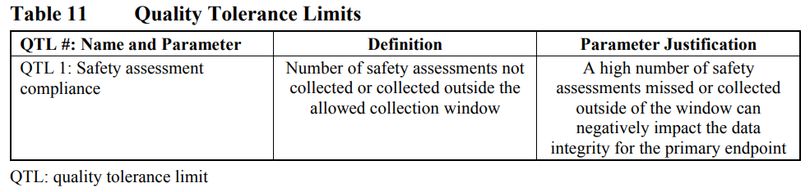

**QTL Management Activities:**

* For control of risks associated with “QTL 1: Safety assessment compliance,” refer to the Schedule of Assessments [Table 1] and Sample Collection Schedule [Table 2]. Additional information regarding the QTL limit and limit justification, as well as associated activities can be found in STL-3458 QTL Monitoring Plan
  1. Source Data

1. Source data must be available at the study site to document the existence of the participants and to substantiate the integrity of study data collected. Source data must include the original documents relating to the study, as well as the medical treatment and medical history of the participant.
2. The investigator must maintain accurate documentation (source data) that supports the information entered in the CRF.
3. The investigator is responsible for ensuring the source data are attributable, legible, contemporaneous, original, accurate and complete whether the data are handwritten on paper or entered electronically. If source data are created (first entered), modified, maintained, achieved, retrieved or transmitted electronically via computerized systems (and/or other kind of electronic devices) as part of regulated study activities, such systems must be compliant with all applicable laws and regulations governing use of electronic records and/or electronic signatures. Such systems may include, but are not limited to, electronic medical/health records, protocol-related assessments, AE tracking, electronic clinical outcome assessment and/or drug accountability.
4. Paper records from electronic systems used in place of electronic format must be certified copies. A certified copy must be an exact copy and must have all the same attributes and information as the original. Certified copies must include signature and date of the individual completing the certification. Certified copies must be a complete and chronological set of study records (including notes, attachments and audit trail information, if applicable). All printed records must be kept in the participant file and be available for archiving.
5. Study monitors will perform ongoing source data verification to confirm that data entered into the CRF by authorized site personnel are accurate, complete and verifiable from source documents; that the safety and rights of participants are being protected; and that the study is being conducted in accordance with the currently approved protocol and any other study agreements, ICH GCP, and all applicable regulatory requirements.
   1. Protocol Deviations

*Not available.*

* 1. Early Site Closure

The study start date is the date the first participant signs the ICF for the study.

The sponsor or designee reserves the right to close the study site or terminate the study at any time for any reason at the sole discretion of the sponsor. Study sites will be closed upon study completion. A study site is considered closed when all required documents and study supplies have been collected and a study-site closure visit has been performed.

The investigator may initiate study-site closure at any time, provided there is reasonable cause and sufficient notice is given in advance of the intended termination.

Reasons for the early closure of a study site by the sponsor or investigator may include but are not limited to:

* For study termination:
* Discontinuation of further study test product development For site termination:
* Failure of the investigator to comply with the protocol, the requirements of the IRB/IEC or local health authorities, the sponsor’s procedures, or GCP guidelines
* Inadequate or no recruitment (evaluated after a reasonable amount of time) of participants by the investigator
* Total number of participants included earlier than expected If the study is prematurely terminated or suspended, the sponsor or designee shall promptly inform the investigators, the IECs/IRBs, the regulatory authorities and any CRO(s) used in the study of the reason for termination or suspension, as specified by the applicable regulatory requirements. The investigator shall promptly inform the participant and should assure appropriate participant therapy and/or follow-up.

1. Appendix: Supporting Details
   1. Clinical Laboratory Tests

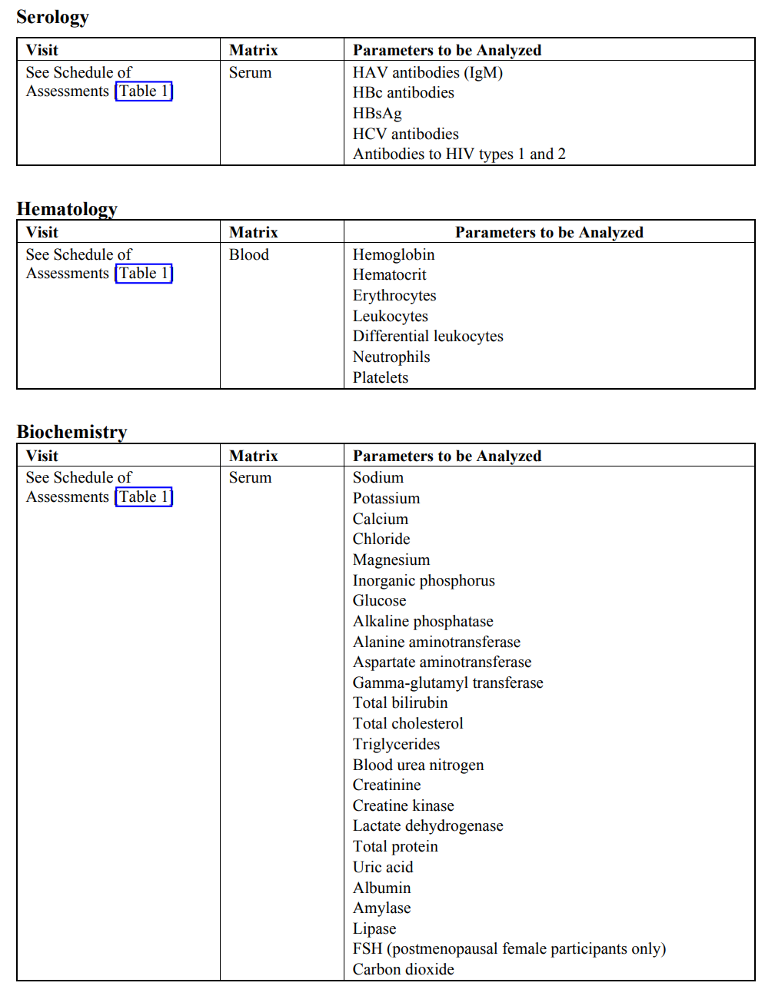

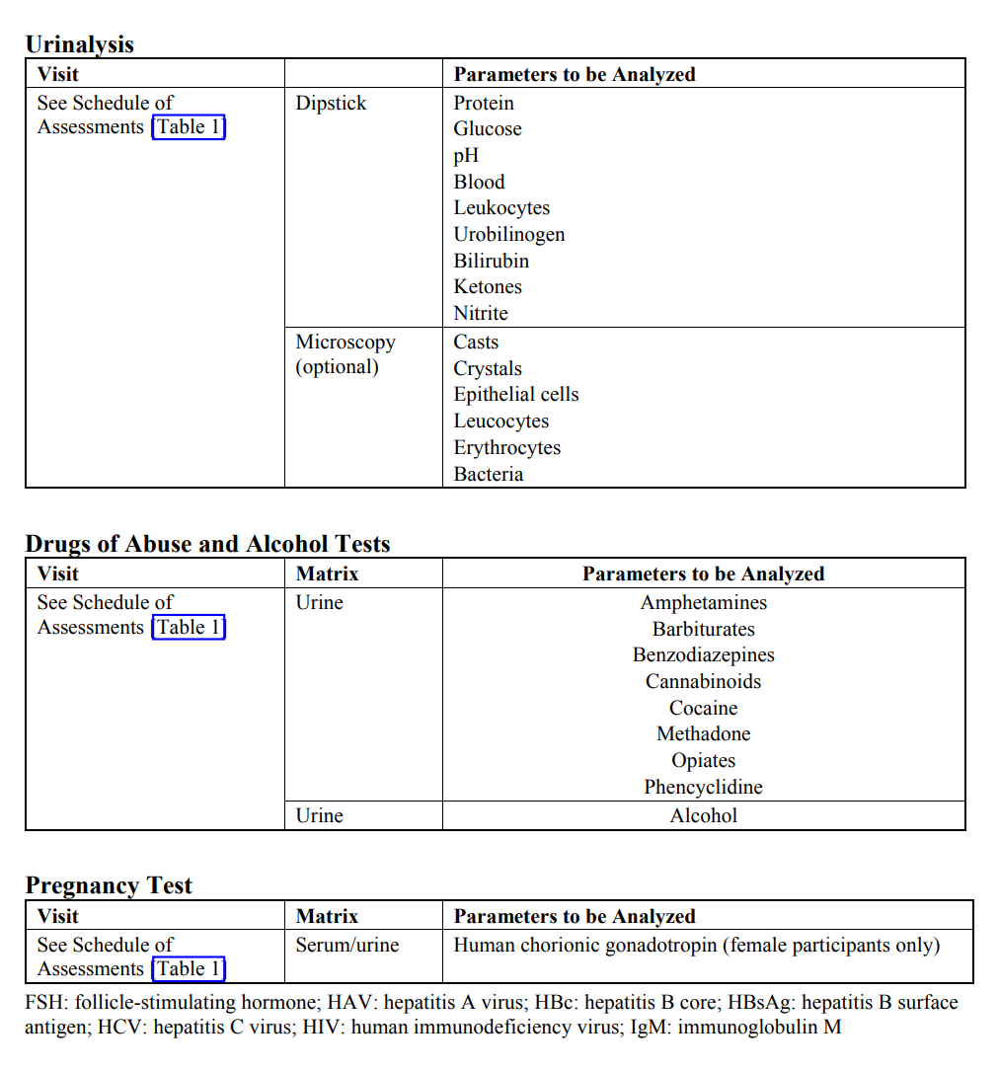

* 1. Country/Region-Specific Differences

Not applicable.

* 1. Prior Protocol Amendment(s)

Not applicable. This is the first protocol amendment.

* 1. Liver Safety Monitoring and Assessment

The purpose of this appendix is to provide guidance for the monitoring of drug-induced liver injury during the course of the study. It should be noted that this section does not specify the end-of-study analyses of liver enzymes. Any participant enrolled in a study with active drug therapy and reveals an increase of serum aminotransferases (AT) to > 3 × ULN or bilirubin > 2 × ULN should undergo detailed testing for liver enzymes (including at least ALP, ALT, AST and TBL). Testing should be repeated within 72 hours of notification of the test results. For studies for which a central laboratory is used, alerts will be generated by the central laboratory regarding moderate and severe liver abnormality to inform the investigator and study team. Participants should be asked if they have any symptoms suggestive of hepatobiliary dysfunction.

**Definition of Liver Abnormalities**

Confirmed abnormalities will be characterized as moderate and severe where ULN is as shown below.

**Table 12 Moderate and Severe Liver Abnormalities**

|  |  |  |  |
| --- | --- | --- | --- |
|  | **ALT or AST** |  | **TBL** |
| Moderate | > 3 × ULN | or | > 2 × ULN |
| Severe | > 3 × ULN | and† | > 2 × ULN |

ALT: alanine aminotransferase; AST: aspartate aminotransferase; TBL: total bilirubin; ULN: upper limit of normal

†Samples taken simultaneously or within a maximum of 24 hours.

In addition, the participant should be considered to have severe hepatic abnormalities for any of the following:

* ALT or AST > 8 × ULN
* ALT or AST > 5 × ULN for more than 2 weeks
* ALT or AST > 3 × ULN and† TBL > 2 × ULN or international normalized ratio (INR) > 1.5 (if INR testing is applicable/evaluated)
* ALT or AST > 5 × ULN and† (TBL > 2 × ULN in participants with liver metastases)
* ALT or AST > 3 × ULN with the appearance of fatigue, nausea, vomiting, right upper quadrant pain or tenderness, fever, rash and/or eosinophilia (> 5%)

†Samples taken simultaneously or within a maximum of 24 hours.

The investigator may determine that abnormal liver function results, other than as described above, may qualify as moderate or severe abnormalities and require additional monitoring and follow-up.

**Follow-up Procedures**

Confirmed moderate and severe abnormalities in hepatic functions should be thoroughly characterized by obtaining appropriate expert consultations, detailed pertinent history, physical examination and clinical laboratory tests. The study site personnel are to complete the liver abnormality case report form (LA-CRF). Participants with confirmed abnormal liver function testing should be followed as described below.

Confirmed moderately abnormal liver function tests should be repeated 2 to 3 times weekly, and then weekly or less if abnormalities stabilize or the IP has been discontinued and the participant is asymptomatic.

Severe hepatic liver function abnormalities as defined above, in the absence of another etiology, may be considered an important medical event and may be reported as an SAE. The sponsor should be contacted and informed of all participants for whom severe hepatic liver function abnormalities possibly attributable to IP are observed.

To further assess abnormal hepatic laboratory findings, the investigator is expected to:

* Obtain a more detailed history of symptoms and prior or concurrent diseases. Symptoms and new-onset diseases are to be recorded as “AEs” within the electronic data source. Illnesses and conditions such as hypotensive events and decompensated cardiac disease that may lead to secondary liver abnormalities should be noted. Nonalcoholic steatohepatitis is seen in obese hyperlipoproteinemic and/or diabetic participants and may be associated with fluctuating AT levels. The investigator should ensure that the medical history form captures any illness that predates study enrollment that may be relevant in assessing hepatic function.
* Obtain a history of concomitant drug use (including nonprescription medication, complementary and alternative medications), alcohol use, recreational drug use and special diets. Medications are to be entered in the electronic data source. Information on alcohol, other substance use and diet should be entered on the LA-CRF or an appropriate document.
* Obtain a history of exposure to environmental chemical agents.
* Based on the participant’s history, other testing may be appropriate including:
  + Acute viral hepatitis (A, B, C, D, E or other infectious agent
  + Ultrasound or other imaging to assess biliary tract disease
  + Other clinical laboratory tests, including INR and direct bilirubin
* Consider gastroenterology or hepatology consultations.
* Submit results for any additional testing and possible etiology on the LA-CRF or an appropriate document.

**Study Treatment Discontinuation**

In the absence of an explanation for increased liver function tests, such as viral hepatitis, pre-existing or acute liver disease, or exposure to other agents associated with liver injury, the participant may be discontinued from study treatment. The investigator may determine that it is not in the participant’s best interest to continue study treatment. Discontinuation of study treatment should be considered if:

* ALT or AST > 8 × ULN
* ALT or AST > 5 × ULN for more than 2 weeks
* ALT or AST > 3 × ULN and† TBL > 2 × ULN or INR > 1.5) (if INR testing is applicable/evaluated)
* ALT or AST > 5 × ULN and† (TBL > 2 × ULN in participants with liver metastases)
* ALT or AST > 3 × ULN with the appearance of fatigue, nausea, vomiting, right upper quadrant pain or tenderness, fever, rash and/or eosinophilia (> 5%)

† Samples taken simultaneously or within a maximum of 24 hours.

In addition, if close monitoring for a participant with moderate or severe hepatic laboratory tests is not possible, study treatment should be discontinued.

Hy’s Law definition: Drug-induced jaundice caused by hepatocellular injury, without a significant obstructive component, has a high rate of bad outcomes, from 10% to 50% mortality (or transplant).

The 2 “requirements” for Hy’s Law are:

1. Evidence that a drug can cause hepatocellular-type injury, generally shown by an increase in AT elevations > 3 × ULN (“2 × ULN elevations are too common in treated and untreated participants to be discriminating”).
2. Cases of increased TBL (at least 2 × ULN) with concurrent AT elevations at least 3 × ULN and no evidence of intra- or extra-hepatic bilirubin obstruction (elevated ALP) or Gilbert’s syndrome [Temple, 2006].

FDA Guidance for Industry titled, “Drug-induced Liver Injury: Premarketing Clinical Evaluation” issued by the FDA on July 2009:

1. The drug causes hepatocellular injury, generally shown by a higher incidence of 3-fold or greater elevations above the ULN of ALT or AST than the (nonhepatotoxic) control drug or placebo.
2. Among participants showing such AT elevations, often with ATs much greater than 3 × ULN, one or more also show elevation of serum TBL to > 2 × ULN, without initial findings of cholestasis (elevated serum ALP).
3. No other reason can be found to explain the combination of increased AT and TBL, such as viral hepatitis A, B, or C; pre-existing or acute liver disease; or another drug capable of causing the observed injury.
   1. Pharmacogenomic Analysis with Banked Sample

**INTRODUCTION**

PGx research aims to provide information regarding how naturally occurring differences in a participant’s gene and/or expression of genes based on genetic variation may impact what treatment options are best suited for the participant. Through investigation of PGx by technologies such as genotyping, gene sequencing, statistical genetics and Genome-Wide Association studies, the relationship between gene profiles and a drug’s kinetics, efficacy, toxicity or disease may be better understood. As many diseases may be influenced by one or more genetic variations, PGx research may identify which genes are involved in determining the way a participant may or may not respond to a drug.

**OBJECTIVES**

The PGx research that may be conducted in the future with acquired blood samples is exploratory. The objective of this research will be to analyze or determine genes of relevance to clinical response, pharmacokinetics and/or toxicity/safety and/or disease. By analyzing genetic variations, it may be possible to predict an individual participant’s response to treatment in terms of efficacy and/or toxicity and/or disease.

**PARTICIPANT PARTICIPATION**

Participants who have consented to participate in this study will participate in the PGx substudy. Participants must provide written consent prior to providing any blood samples that may be used at a later time for PGx analysis.

**SAMPLE COLLECTION AND STORAGE**

Participants who consent to participate in this substudy will provide 4 mL sample of whole blood per Astellas’ instructions. Each sample will be identified by the unique participant number. Samples will be shipped to a designated banking CRO as directed by Astellas.

**PGx ANALYSIS**

Details on the potential PGx analysis cannot be established yet. Astellas may initiate the PGx analysis if evidence suggests that genetic variants may be influencing the drug’s pharmacokinetics, efficacy and/or safety and/or disease.

**DISPOSAL OF PGx SAMPLES/DATA**

All PGx samples collected will be stored for a period of up to 15 years following study database lock. If there is no requirement for analysis, the whole blood sample will be destroyed after the planned storage period. The participant has the right to withdraw consent at any time. When a participant’s withdraw notification is received, the PGx sample will be destroyed. The results of any PGx analysis conducted on a sample prior to its withdrawal will be retained at Astellas indefinitely unless otherwise specified by local regulation.

**INFORMATION DISCLOSURE TO THE PARTICIPANTS**

Exploratory PGx analysis may be conducted following the conclusion of the study, if applicable. The results of the PGx analysis will not be provided to any investigators or participants, nor can the results be requested at a later date. Any information that is obtained from the PGx analysis will be the property of Astellas

* 1. Columbia Suicide-Severity Rating Scale

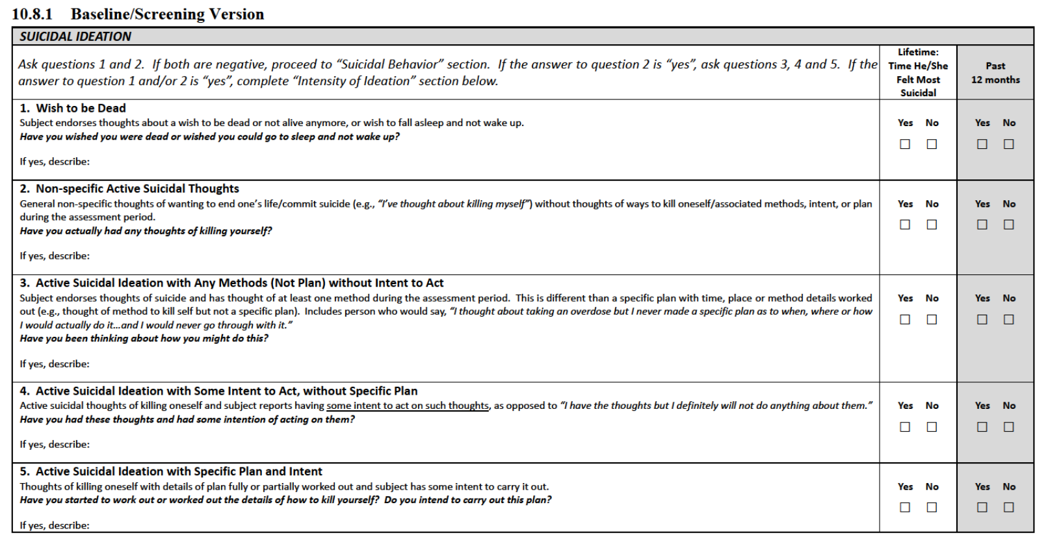

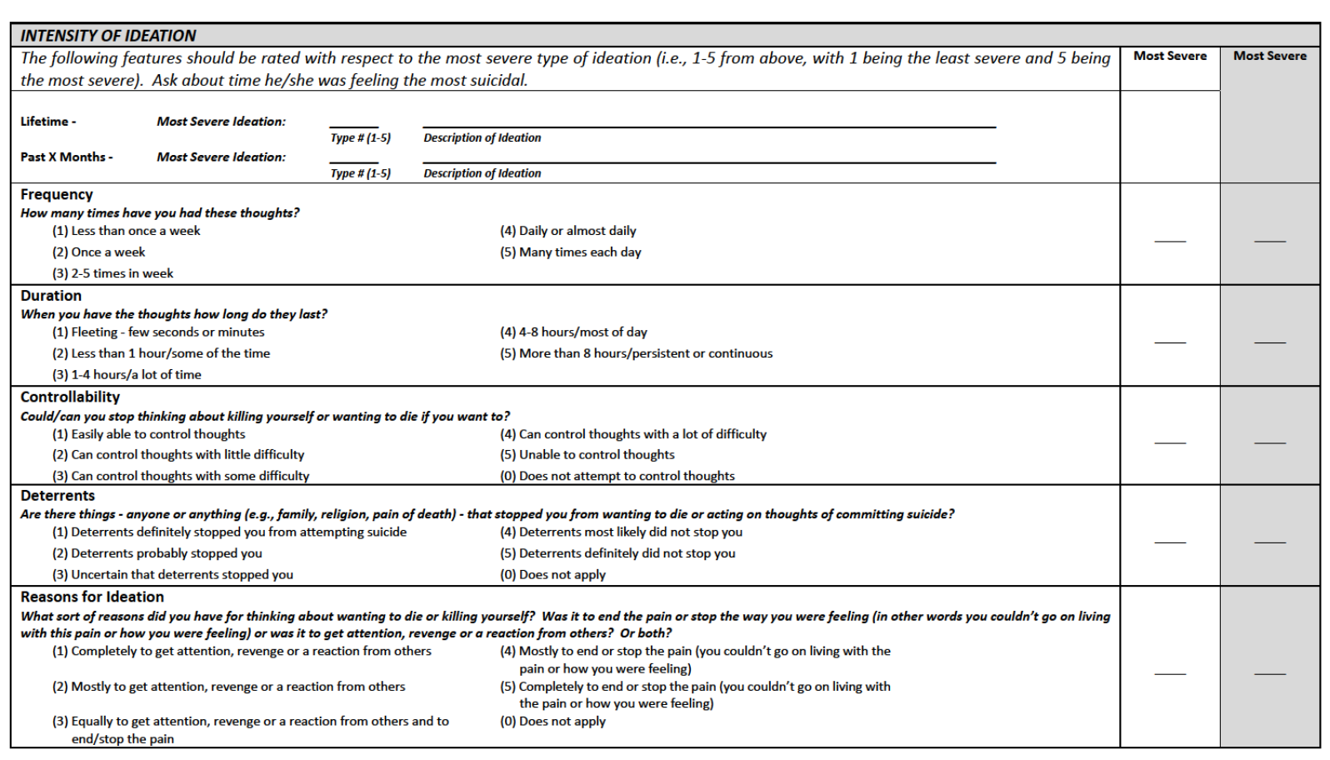

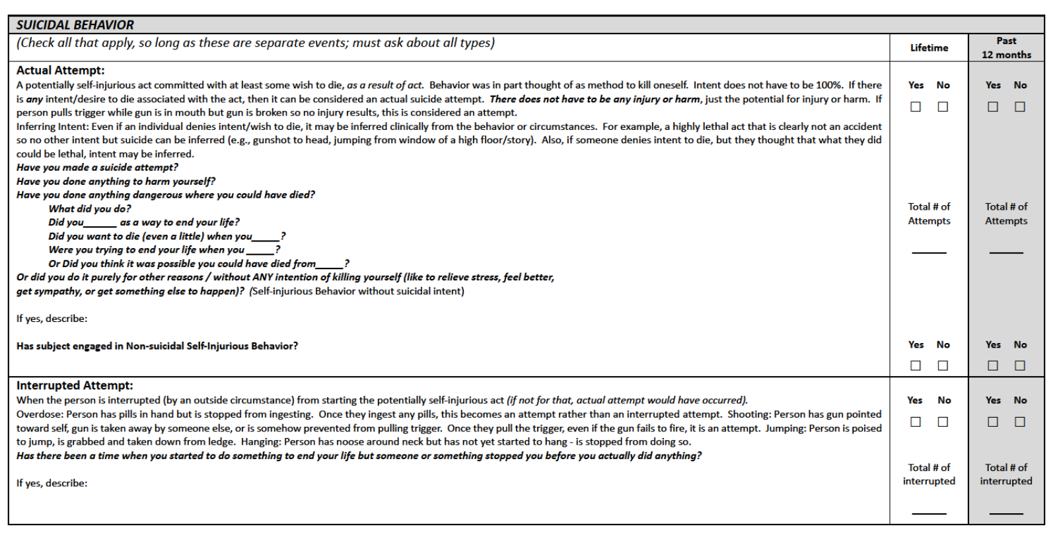

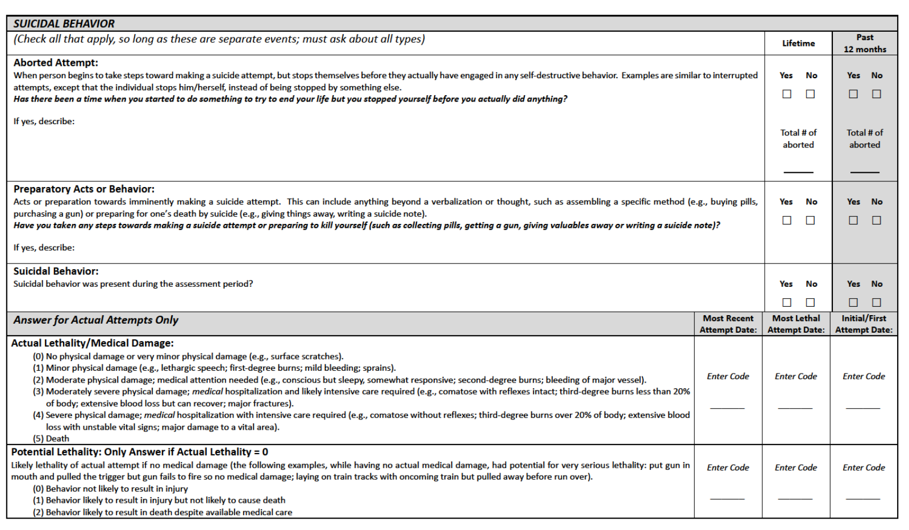

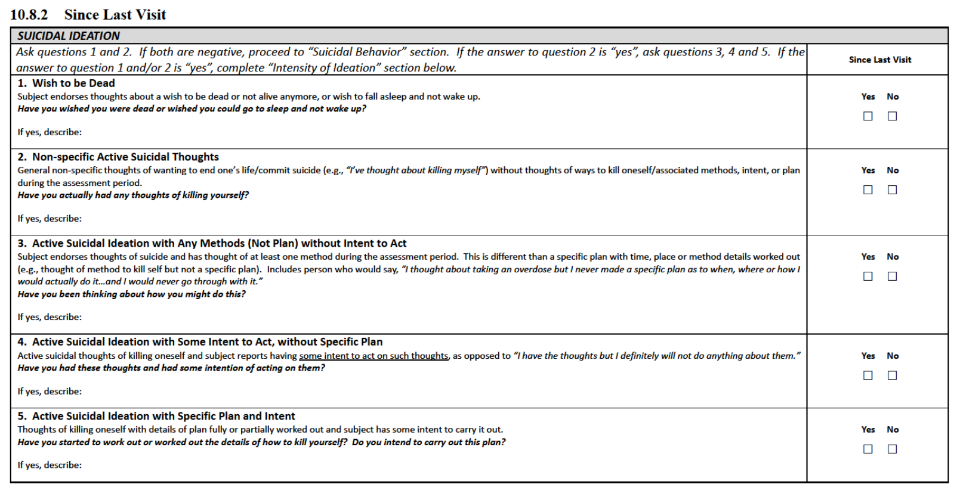

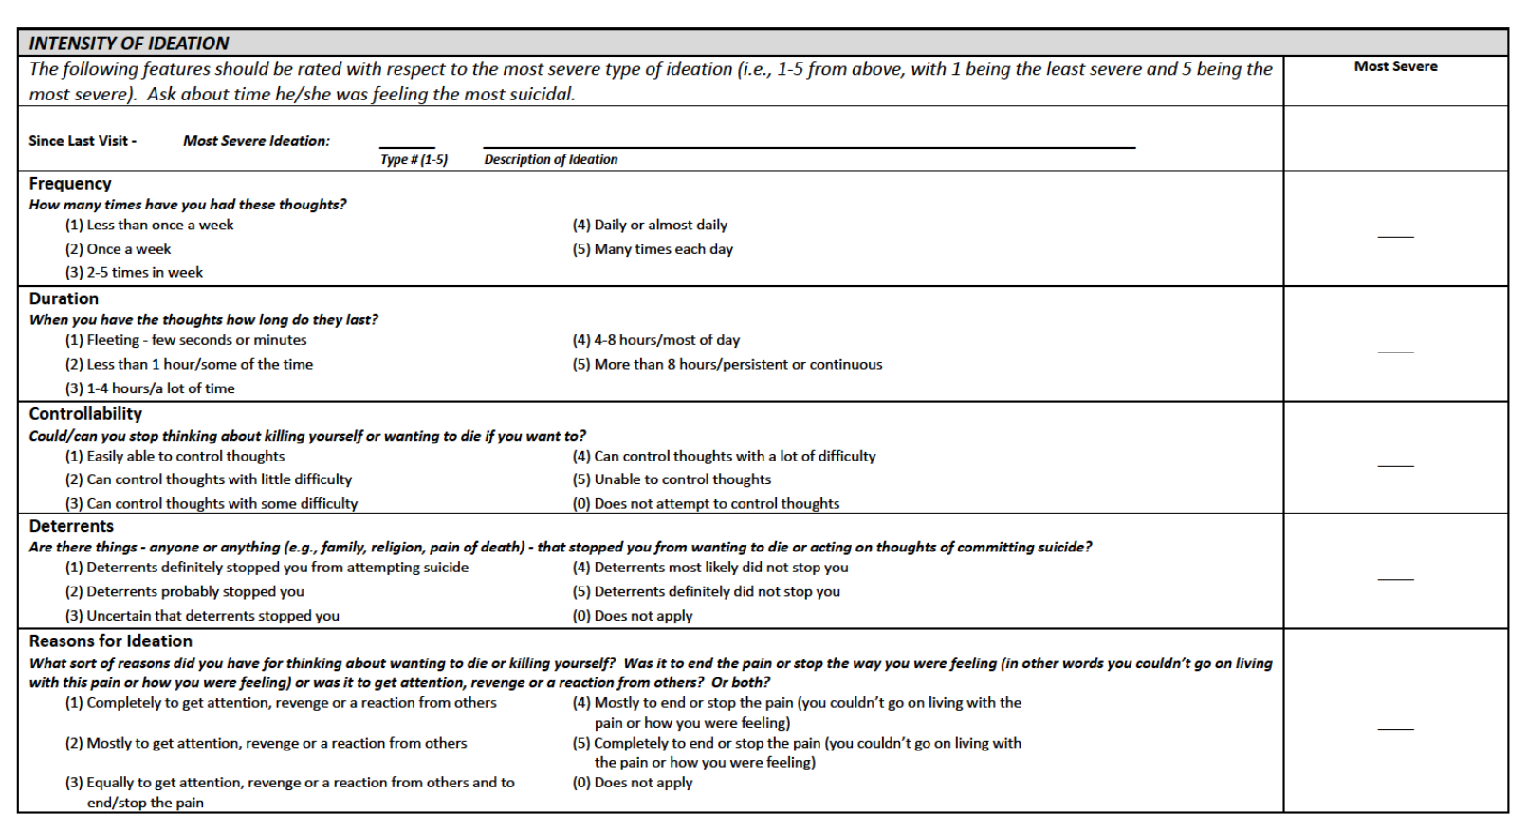

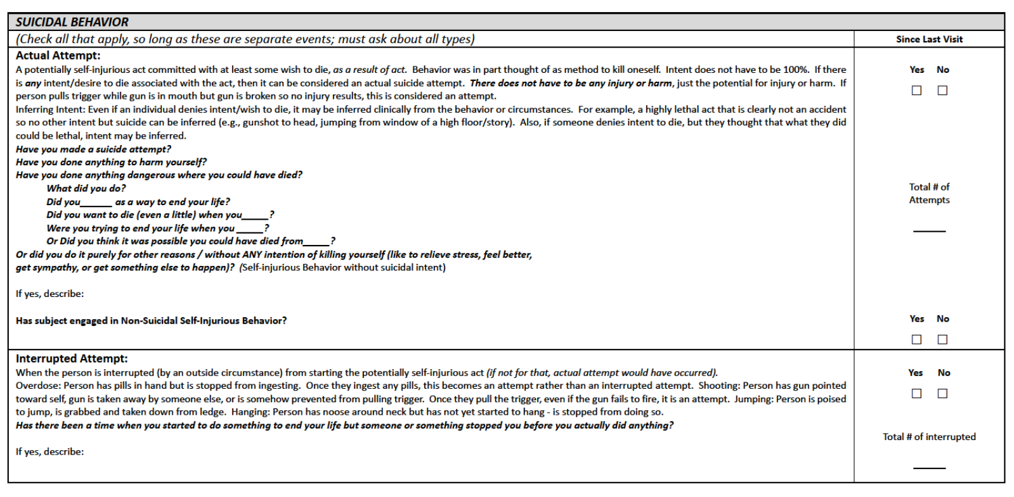

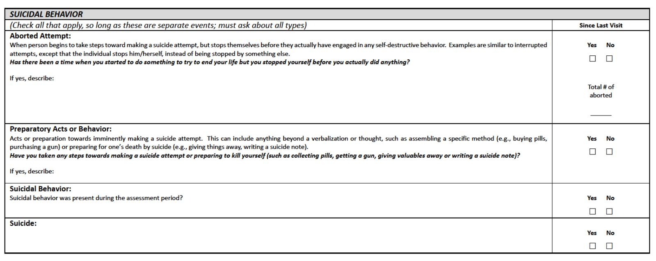

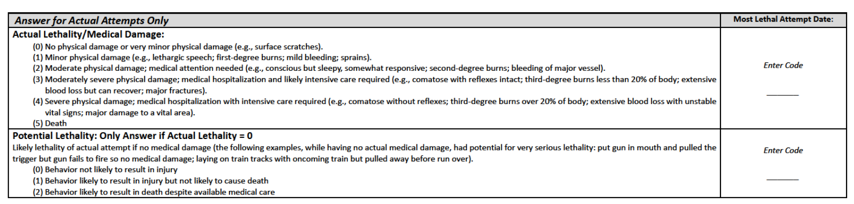

* 1. 49-item Short Form of Addiction Research Center Inventory Scale

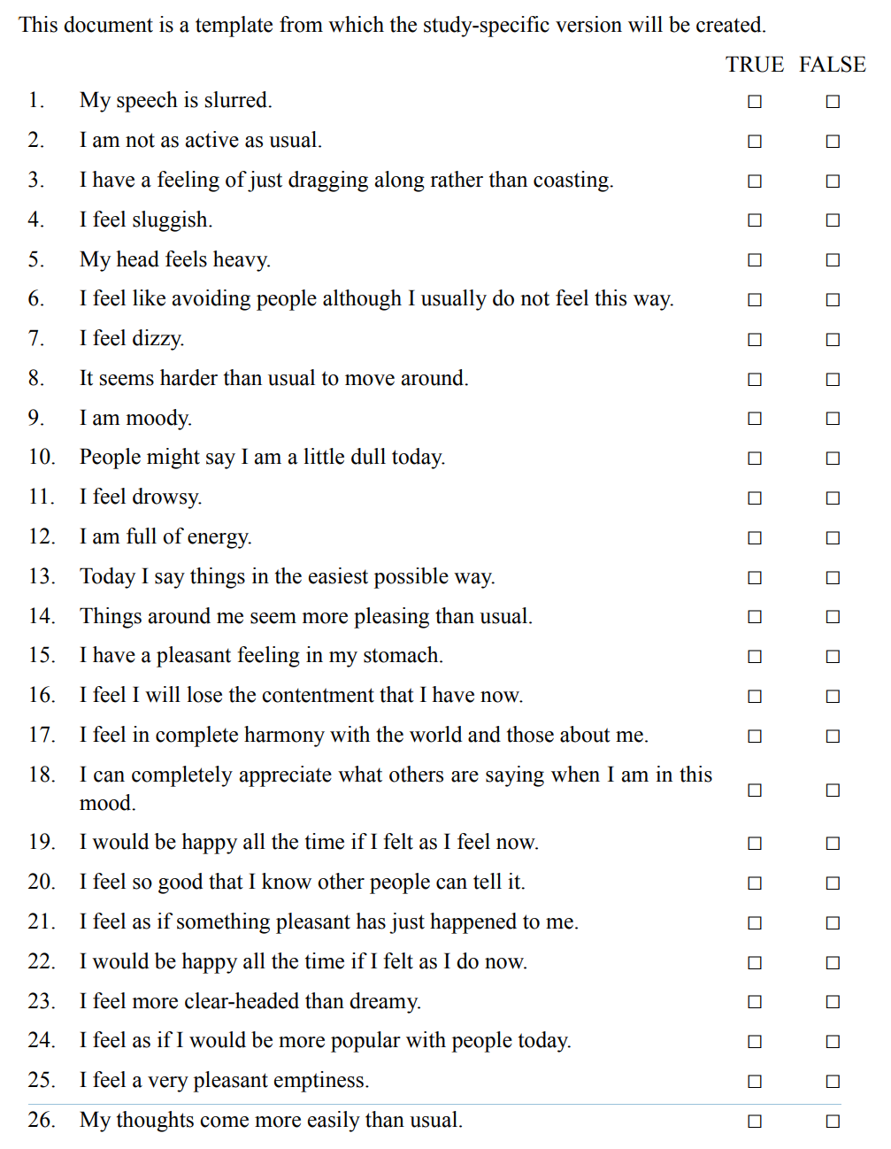

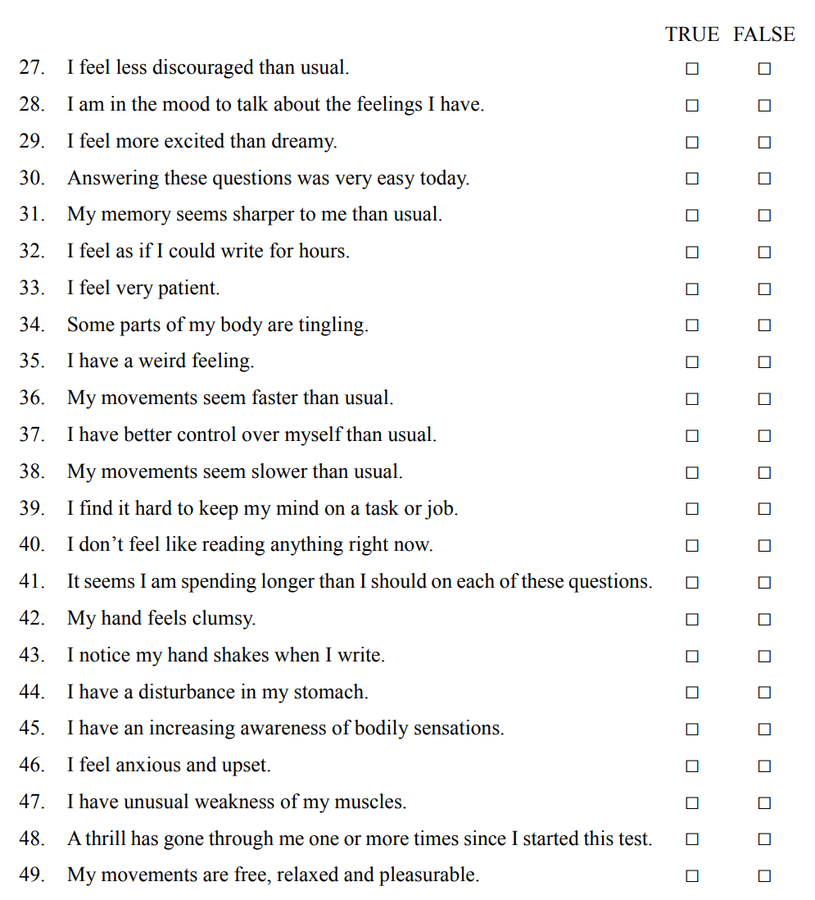

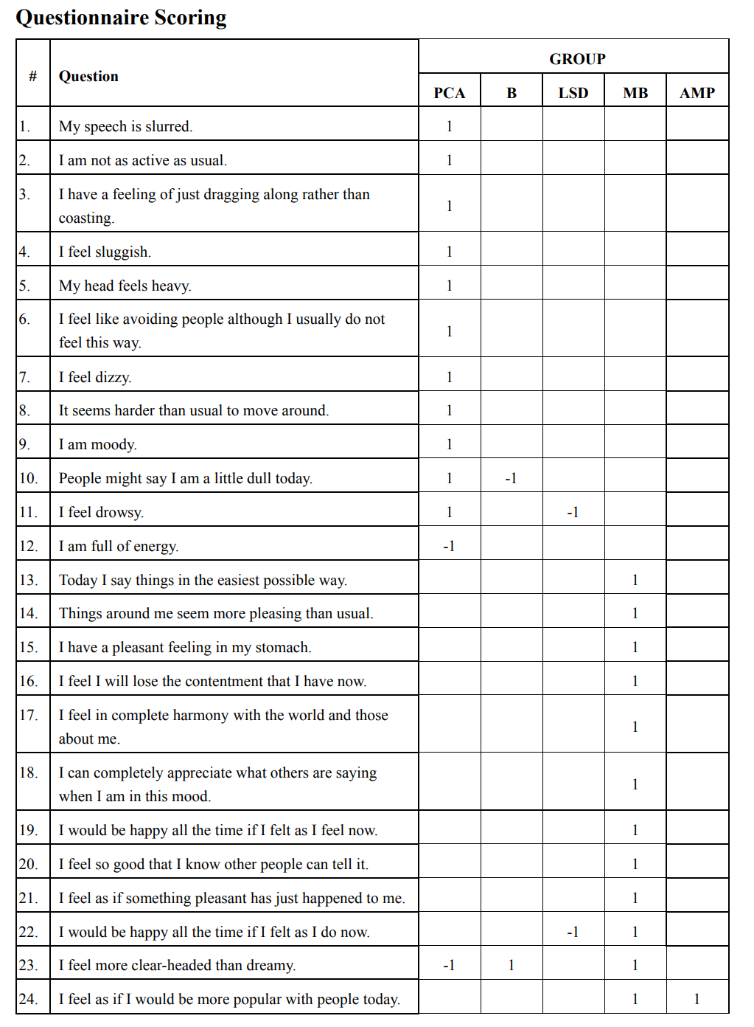

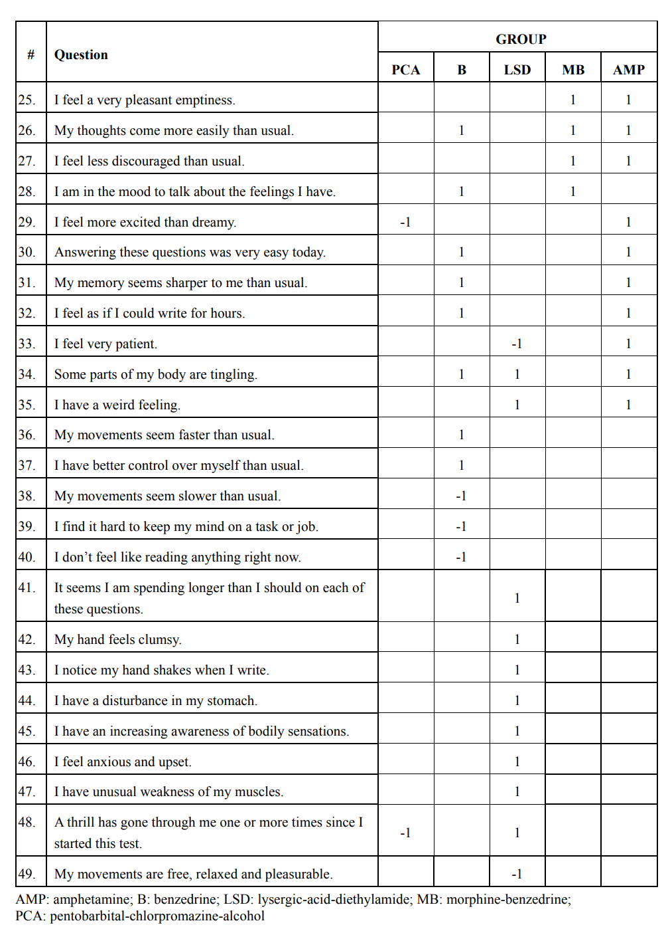

* 1. Adverse Events of Interest Related to Potential Substance Abuse and Following Drug Withdrawal

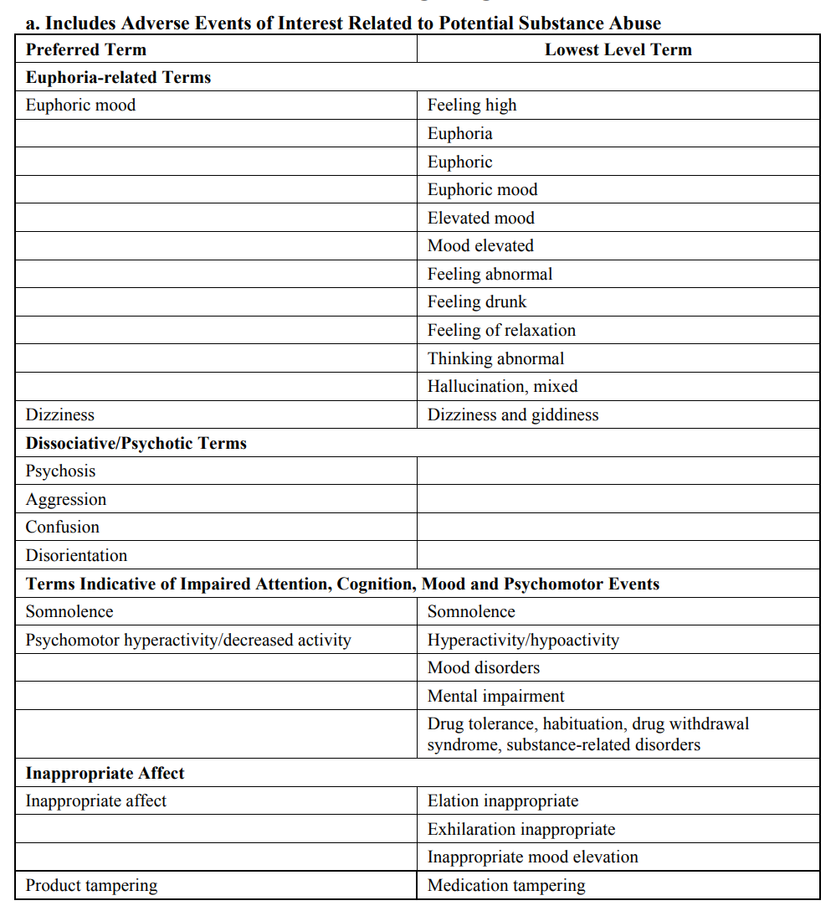

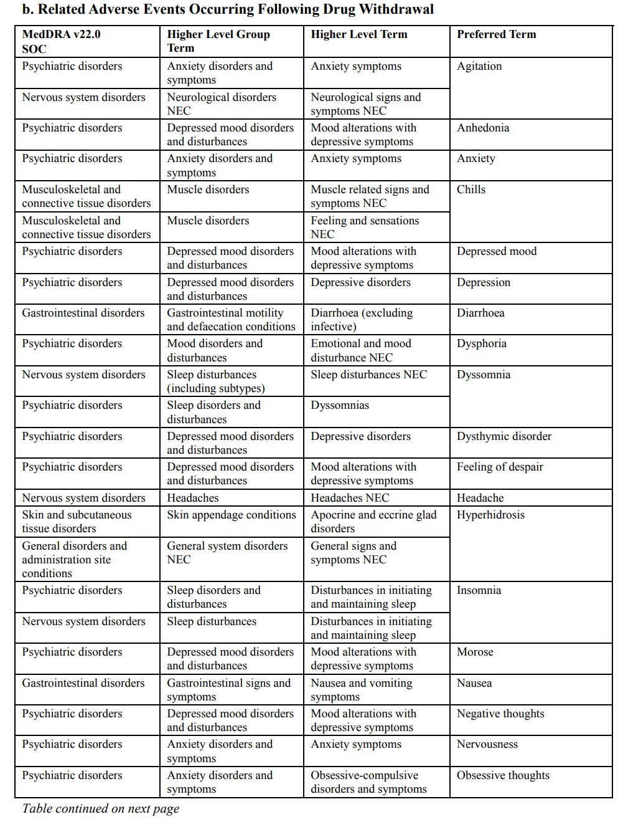

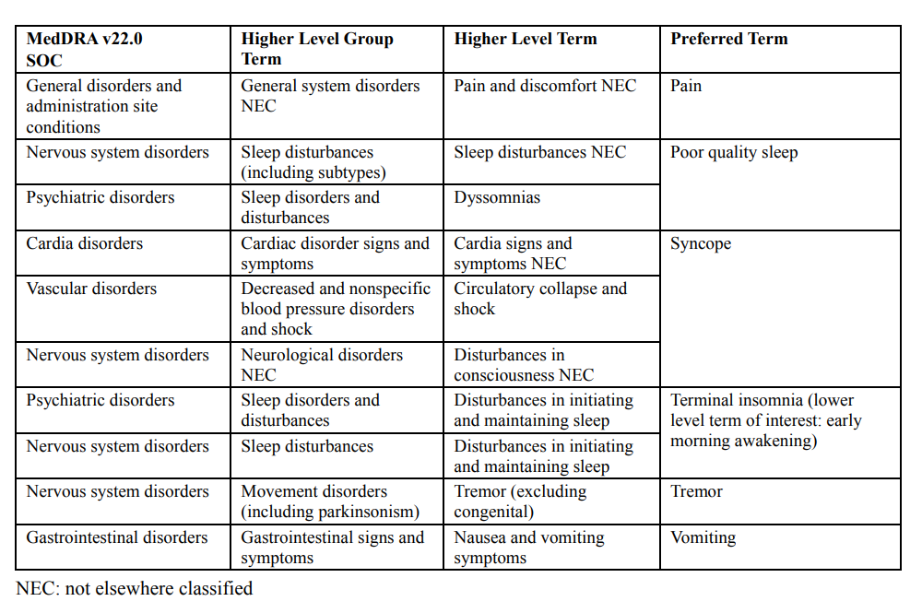

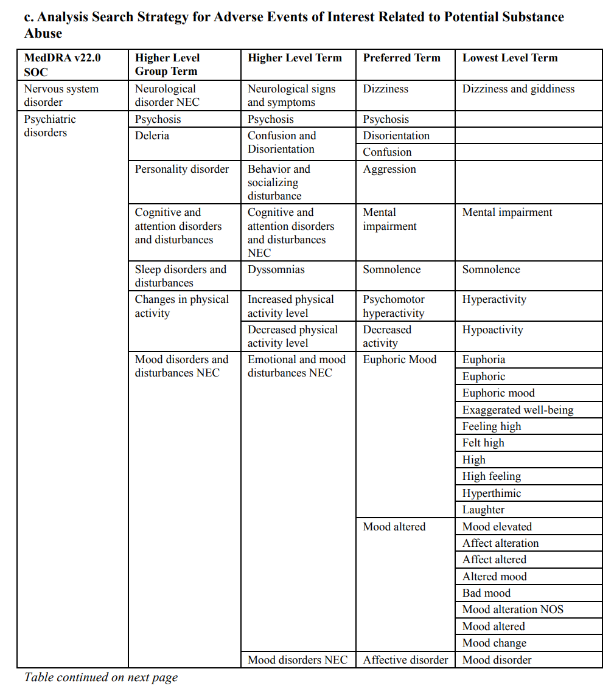

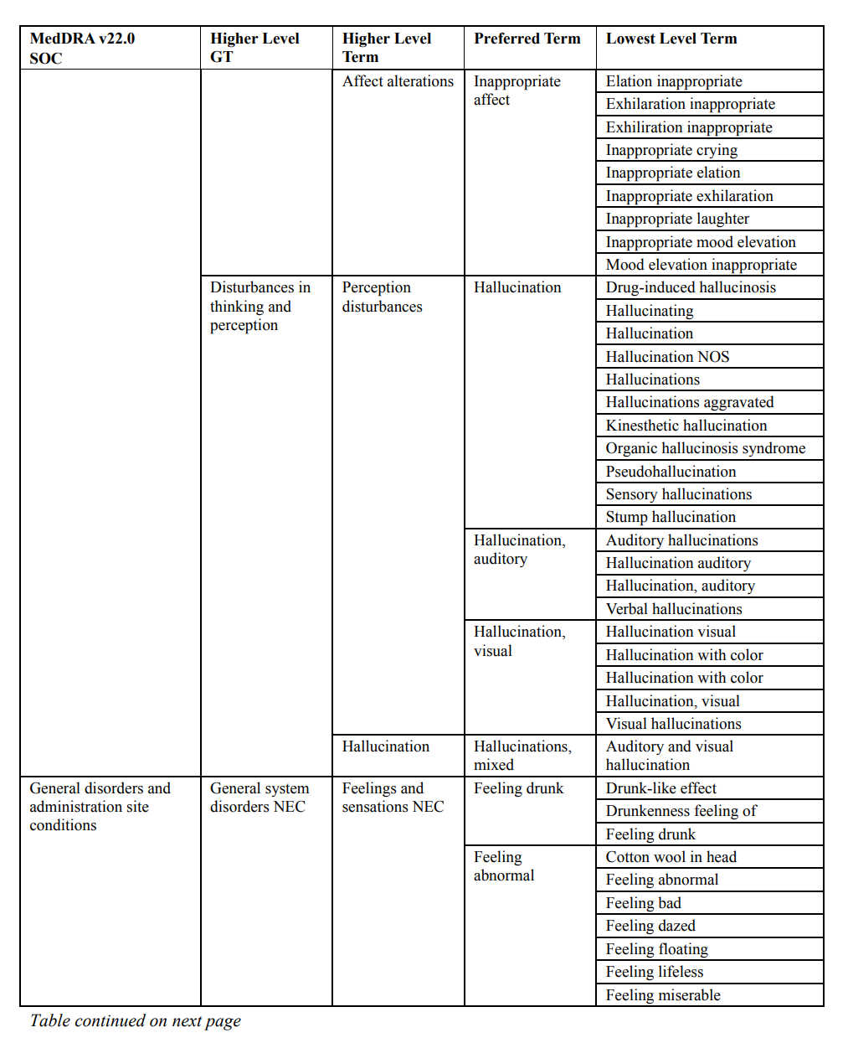

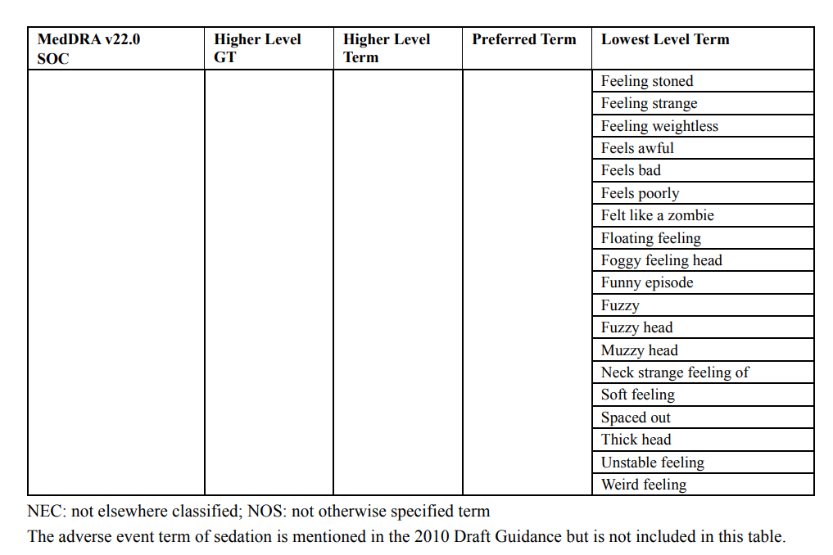

1. Appendix: Glossary of Terms and Abbreviations

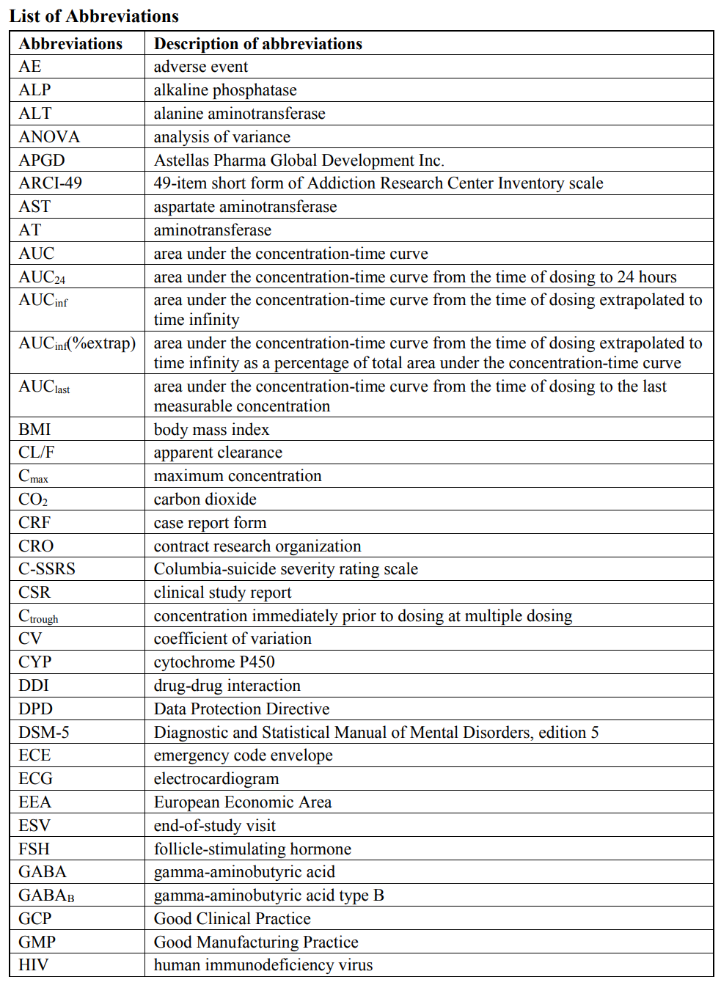

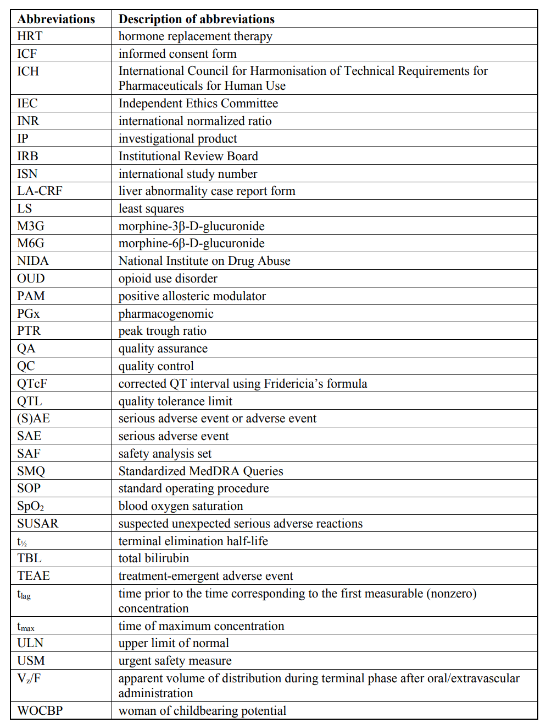

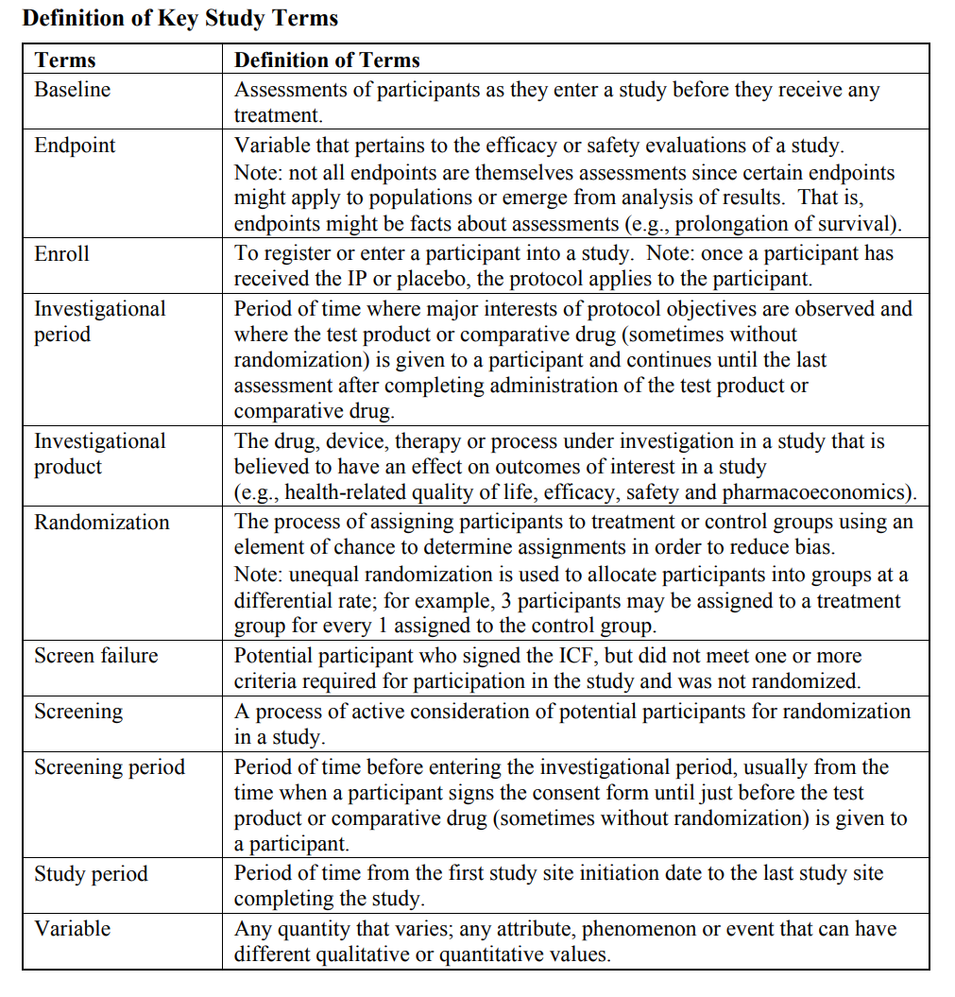

1. Appendix: References

Augier E, Dulman RS, Damadzic R, Pilling A, Hamilton JP, Heilig M. The GABAB positive allosteric modulator ADX71441 attenuates alcohol self-administration and relapse to alcohol seeking in rats. Neuropsychopharmacology. 2017;42:1789-99.

Bart G. Maintenance medication for opiate addiction: the foundation of recovery. J Addict Dis. 2012;31:207-25.

Bowery NG, Bettler B, Froestl W, Gallagher JP, Marshall F, Raiteri M, et al. International Union of Pharmacology. XXXIII. Mammalian γ-aminobutyric acidB receptors: structure and function. Pharmacol Rev. 2002;54:247-64.

Center for Drug Evaluation and Research. Clinical Pharmacology and Biopharmaceutics Review(s): Morphine Sulfate Oral Solution and Tablets [Internet]. 2008 [cited 17 Apr 2020]. Available from: https://www.accessdata.fda.gov/drugsatfda_docs/nda/2008/022195s000_022207s000_ClinPhar mR.pdf

Court MH, Krishnaswamy S, Hao Q, Duan SX, Patten CJ, Von Moltke LL, et al. Evaluation of 3'-azido-3'-deoxythymidine, morphine, and codeine as probe substrates for UDP-glucuronosyltransferase 2B7 (UGT2B7) in human liver microsomes: specificity and influence of the UGT2B7*2 polymorphism. Drug Metab Dispos. 2003;31:1125-33.

Dario A, Tomei G. A benefit-risk assessment of baclofen in severe spinal spasticity. Drug Saf. 2004;27:799-818.

De Gregori S, De Gregori M, Ranzani GN, Allegri M, Minella C, Regazzi M. Morphine metabolism, transport and brain disposition. Metab Brain Dis. 2012;27:1-5.

Di Ciano P, Everitt BJ. The GABA(B) receptor agonist baclofen attenuates cocaine- and heroin-seeking behavior by rats. Neuropsychopharmacology. 2003a;28:510-8.

Di Ciano P, Everitt BJ. Differential control over drug-seeking behavior by drug-associated conditioned reinforcers and discriminative stimuli predictive of drug availability. Behav Neurosci. 2003b;117:952-60.

Filip M, Frankowska M. Effects of GABA(B) receptor agents on cocaine priming, discrete contextual cue and food induced relapses. Eur J Pharmacol. 2007;571:166-73.

Filip M, Frankowska, M, Sadakierska-Chudy A, Suder A, Szumiec L, Mierzejewski P, et al. GABAB receptors as a therapeutic strategy in substance use disorders: Focus on positive allosteric modulators. Neuropharmacology. 2015;88:36-47.

Franklin TR, Harper D, Kampman K, Kildea-McCrea S, Jens W, Lynch KG, et al. The GABAB agonist baclofen reduces cigarette consumption in a preliminary double-blind placebo-controlled smoking reduction study. Drug Alcohol Depend. 2009;103:30-6.

Haaz MC, Riché C, Rivory LP, Robert J. Biosynthesis of an aminopiperidino metabolite of irinotecan [7-ethyl-10-[4-(1-piperidino)-1-piperidino]carbonyloxycamptothecine] by human hepatic microsomes. Drug Metab Dispos. 1998;26:769-74.

Haertzen CA, Hill HE, Belleville RE. Development of the addiction research center inventory (ARCI): selection of items that are sensitive to the effects of various drugs. Psychopharmacologia 1963;4:155–66.

Hasin DS, O’Brien CP, Auriacombe M, Borges D, Bucholz K, Budney A, et al. DSM-5 criteria for substance use disorders: recommendations and rationale. Am J Psychiatry. 2013;170:834-51.

Investigator’s Brochure ASP8062, Astellas.

Martin WR, Sloan JW, Sapira JD, Jasinski DR. Physiologic, subjective, and behavioral effects of amphetamine, methamphetamine, ephedrine, phenmetrazine, and methylphenidate in man. Clin Pharmacol Ther. 1971;12:245-58.

Mattick RP, Breen C, Kimber J, Davoli M. Methadone maintenance therapy versus no opioid replacement therapy for opioid dependence. Cochrane Database Syst Rev. 2009;(3):CD002209. Mattick RP, Breen C, Kimber J, Davoli M. Buprenorphine maintenance versus placebo or methadone maintenance for opioid dependence. Cochrane Database Syst Rev. 2014;(2):CD002207.

Møller IW, Vester-Anderson T, Steentoft A, Hjortsø E, Lunding M. Respiratory depression and morphine concentration in serum after epidural and intramuscular administration of morphine. Acta Anaesth Scand. 1982;26:421-4.

Morphine Sulfate Tablets (highlights of prescribing information). West-Ward Pharmaceuticals Corp; Oct 2019.

NIDA: National Institute on Drug Abuse; National Institutes of Health; U.S. Department of Health and Human Services. Dramatic Increases in Maternal Opioid Use and Neonatal Abstinence Syndrome [Internet]. Rockville, MD: National Institutes of Health; 2019a [updated 2019 Jan; cited 2019 Aug 07]. Available from: https://www.drugabuse.gov/related-topics/trendsstatistics/infographics/dramatic-increases-in-maternal-opioid-use-neonatal-abstinencesyndrome

NIDA: National Institute on Drug Abuse; National Institutes of Health; U.S. Department of Health and Human Services. Drug Use and Viral Infections (HIV, Hepatitis) [Internet]. Rockville, MD: National Institutes of Health; 2019b [updated 2019 Jul; cited 2019 Aug 07]. Available from: <https://www.drugabuse.gov/publications/drugfacts/drug-use-viral-infections-hiv-hepatitis>

Olsen RW, Sieghart W. International Union of Pharmacology. LXX. Subtypes of γ-aminobutyric acidA receptors: classification on the basis of subunit composition, pharmacology, and function. Update. Pharmacol Rev. 2008;60:243-60.

Paterson NE, Froestl W, Markou A. The GABAB receptor agonists baclofen and CGP44532 decreased nicotine self-administration in the rat. Psychopharmacology (Berl). 2004;172:179-86.

Paterson NE, Vlachou S, Guery S, Kaupmann K, Froestl W, Markou A. Positive modulation of GABA(B) receptors decreased nicotine self-administration and counteracted nicotine-induced enhancement of brain reward function in rats. J Pharmacol Exp Ther. 2008;326:306-14.

Pattinson KTS. Opioids and the control of respiration. Fr. J. Anaesth. 2008;100:747-58

Posner K, Brent D, Lucas C, Gould M, Stanley B, Brown G, et al. Columbia-Suicide Severity Rating Scale: Baseline/Screening Version and Since Last Visit. New York, NY: The Research Foundation for Mental Hygiene: 2009.

Projean D, Morin PE, Tu TM, Ducharme J. Identification of CYP3A4 and CYP2C8 as the major cytochrome P450 s responsible for morphine N-demethylation in human liver microsomes. Xenobiotica. 2003;33:841-54.

Rasmussen, K, White DA, Acri JB. NIDA’s medication development priorities in response to the Opioid Crisis: ten most wanted. Neuropsychopharmacology. 2019;44:657-9.

Sato Y, Nagata M, Kawamura A, Miyashita A, Usui T. Protein quantification of UDP-glucuronosyltransferases 1A1 and 2B7 in human liver microsomes by LC-MS/MS and correlation with glucuronidation activities. Xenobiotica. 2012;42:823-9.

Schiller EY, Mechanic OJ. Opioid overdose. [Updated Dec2019]. In: StatPearls [Internet]. Treasure Island (FL): StatPearls Publishing; 2020 Jan-. Available from: <https://www.ncbi.nlm.nih.gov/books/NBK470415/>

Scholl L, Seth P, Kariisa M, Wilson N, Baldwin G. Drug and opioid-involved overdose deaths - United States, 2013–2017. MMWR Morb Mortal Wkly Rep 2018;67:1419–27.

Schwartz RP, Gryczynski J, O’Grady KE, Sharfstein JM, Warren G, Olsen Y, et al. Opioid agonist treatments and heroin overdose deaths in Baltimore, Maryland, 1995-2009. Am J Public Health. 2013;103:917-22.

Slattery DA, Markou A, Froestl W, Cryan JF. The GABAB receptor-positive modulator GS39783 and the GABAB receptor agonist baclofen attenuate the reward-facilitating effects of cocaine: intracranial self-stimulation studies in the rat. Neuropsychopharmacology. 2005;30:2065-75.

Substance Abuse and Mental Health Services Administration. Key substance use and mental health indicators in the United States: Results from the 2017 National Survey on Drug Use and Health (HHS Publication No. SMA 18-5068, NSDUH Series H-53). Rockville, MD: Center for Behavioral Health Statistics and Quality, Substance Abuse and Mental Health Services Administration. 2018 [accessed 2019 Aug 07]. Available from: https://www.samhsa.gov/data/sites/default/files/cbhsqreports/NSDUHFFR2017/NSDUHFFR2017.pdf

Temple R. Hy’s Law: Predicting Serious Hepatotoxicity. Pharmacoepidemiol Drug Saf. 2006;15(4):241-3.

Vlachou S, Guery S, Froestl W, Banerjee D, Benedict J, Finn MG, et al. Repeated administration of the GABAB receptor positive modulator BHF177 decreased nicotine self-administration, and acute administration decreased cue-induced reinstatement of nicotine-seeking in rats. Psychopharmacology (Berl). 2011;215:117-28